

**BeautéPanda: Android Application For Beauty Enthusiasts**

**BIT304 FINAL YEAR PROJECT I**

(E1500352) Ayu Chrisniyanti

(E1500367) Lovely

Submitted to the

FACULTY OF COMPUTING AND DIGITAL TECHNOLOGY

(SCHOOL OF INFORMATION AND COMMUNICATION TECHNOLOGY)

In partial fulfilment of the requirements

for the degree of

Bachelor of Information Technology (HONS)

HELP UNIVERSITY

SEPTEMBER - DECEMBER 2018

# Abstract

In Bali, we are a bit difficult to find Makeup Artist or Beauty Salons in one place.

LOVE AKU PUSING ☹

# Declaration

We hereby declare that this final year report presented here as part of the requirement of BIT304 is original and there are no parts of this final year report that had been plagiarised from any other resources unless those indicated with proper referencing. This report will be the property of HELP University and STIKOM Bali and cannot be distributed in any form without the written consent of HELP University and STIKOM Bali.

Student Names:

Ayu Chrisniyanti Lovely

Date: December 20, 2018

# Acknowledgement

This project will not be possible without the help of a number of people. We would like to express our deepest gratitude to Mr. Yudi Agusta and Ms. Anitha Velayutham who has provided guidance, suggestion and insight in our project development. We also thank our family and colleague who supported and encouraged us during the hardest time in our project. Last but not least, we would like to thank the God almighty who gave us strength and ease during the work of this project and allowed us to finish this project.

Tolong tambahin mak ☹ aku pusinggg biar gak mirip kata2nya

Table of content

# CHAPTER 1: PROPOSAL

## 1.1 Introduction

In this Era, from year to year many people want to look beautiful everyday especially for all women. If we talk about beauty, it will always be related to makeup. Over time, makeup has grown rapidly. It has become a ‘daily need’ for women. Many people like to browse the internet with the keyword *‘makeup’* to get inspirations and to learn how to do their makeup. This signifies that the development of makeup trends from year to year is increasing. The problem is not many people have time to do makeup on their own and not many people have time to learn and practice for makeup. Therefore, most people deicide to use beauty salons or makeup artist to help them.

In Bali many events such a wedding party, graduation, and so on, that require women to have makeup and look beautiful. and it need helps from the makeup artist to make look more beautiful. There are many people who provide beauty services and it makes the customers confused to choose which makeup artist or salon that have good price, have better quality, and so on. The other problem is the customer should find the information about makeup artists one by one in the internet or social media such an *Instagram*. It will take much time for the customers to hire for one makeup artist.

Therefore, we would like to solve this problem by developing a mobile application. This Android – based application is developed with the name of BeautéPanda. This application provides the user with a lot of features that will facilitate both the customer and the makeup artist. For the customer’s side, this application will help customer to find makeup artists easily and the customer can contact the them directly through the ‘*inbox’* menu that are provided on the application. Also, the customer can read beauty related news. For the makeup artist’s or salon’s side, this application will help them to make the appointment with the customer easily. Also, the makeup artist or salon can post photos as their catalogue to increase the customer’s desire. We hope this application would solve those problems, to help both the customer and the makeup artist or Salon, and also useful for them.

## 1.2 Issues with Current System

In Bali, there are many makeup artists or salon that we can meet in many areas and we can find one by one in the internet or social media. Only few applications that provided beauty services for customer, for example in Indonesia only two applications that provided these services such as GO GLAM by GOJEK and SALON by HOUZCALL, but none of them provided the customer for makeup, hair-do (*e.g. hair do for wedding, and etc.*), and nails (*e.g. nails art, nails extension, and etc.*) services. However, those application only provide some services such as manicure and pedicure, haircut, hair colouring, and so on that are already common in traditional beauty salons.  Therefore, we want to make a mobile application for this kind of issues. We believe it will help both customers and makeup artists or salon with some features that we add on the application.

## 1.3 Benefits and Constraints of Proposed System

After we discussed about beauty issues that happened nowadays, we want to develop an Android – based application that will help the customer to find a makeup artist or salon and help the customer to communicate with makeup artist or salon to make appointment or ask for the information. Also, this application will help the makeup artist or salon to communicate easily with the customer, post a photo as their catalogue, and to increase the business profit. Beside that, the customer and MUA or salon can read news that are provided on the application about beauty issues.

All the benefits aside, this application still have some constraints that have to be concerned about. With this application the customer only can pay the service by cash which this application did not provide any online transactions. Another constraint is that the customers cannot change the schedule that already confirmed and the customers cannot cancel the appointment on the day of the appointment. However, we want to develop this application so that it will be easy to use for everyone. We hope through this approach we can help makeup artist or salon to reach the customers.

## 1.4 Project Keywords

* Makeup Artist (MUA)
* Salon or Beauty Salons
* Appointment
* Beauty Categories

## 1.5 Direct Customers / Beneficiaries of The Project

This application will be used for both the customers and makeup artists or salon to make appointment easily with each other, and store the portfolio of the makeup artists or salon.The customers that will be used this application come from all ages and it is mostly used by women. In this application, the customers can find information about makeup artists or salon that they want, they can send messages to makeup artists or salon to make appointment or just to ask about more specific information about that MUA or salon. Also, the customers can read the beauty related news that provide on the application.

For the makeup artists or salons, they can make reply messages from the customers to answer their questions. The makeup artists or salon can post photos as their portfolio on their album, so the customers can see what services that are provided by them and can see the results of the makeup. Additionally, the makeup artists or salon can read the beauty related news on the application.

## 1.6 Project Description

BeautéPanda is an android application that serves as a place of commerce that connects customers with sellers who offer makeup, hairdo and nails services. This application has two types of user, which are customer and seller (salon or makeup artist). Through this application, a user can register as a customer and he/she will be able to find salons or makeup artists and read information about the services offered. On the other hand, a user can register as a seller that offer beauty services. After that, the seller can upload photos for the services he/she offers and add descriptions and price range to attract customers.

To make a deal and confirm the transaction, customer can send personal message to the seller and decide on their own where and when the service will be given. The seller can ask the customer to come to his/her salon or beauty studio to receive the service, or the seller can provide home – service to the customer. The payment method is similar to “Uber” or “Grab” application which will be done directly between customer and seller on their appointment location, after the service has been delivered. To prevent the customer or the seller to forget about their appointment, the application will provide a confirmation feature that should be agreed by both parties, and the application will send notification 24 hours and 2 hours before the appointment time.

BeautéPanda also provides general information and news about beauty and the latest trends in the industry. The news will be gathered by the application’s administrator and he/she will handle which contents will be displayed. Another task of the admin is to manage ‘help’ section to inform customers about the application in general.

Below are the features of BeautéPanda in details:

* **Register/Login:** user can register as seller (makeup artist or salon) or customer by providing full name, password and email address. To login, user has to input his/her email and password.
* **Services:** the application will show a list of service categories e.g. makeup, hairdo, etc., and photos of the services from the sellers
* **Search**: this is a feature for customer users, so that they can directly search for a specific category or seller
* **Message and Confirmation:** this feature allows customer to ask seller about any information regarding the service being offered, and discuss about their appointment. After agreeing on place, time and price, seller can create an order and customer should confirm the order.
* **Order List and Reminder:** from the seller point of view, this will display list of orders from customers. From the customer point of view, this will display list of appointment that the customer has made with the seller. The application will send notification 24 hours and 2 hours before an appointment so that both parties will remember.
* **Favorites:** this is a feature for the customer, where he/she can ‘bookmark’ services that he/she has interest on, so that the customer can easily find them
* **Ratings:** this is a feature for the customer, where he/she can give feedback and ratings for the sellers
* **News:** this feature provides latest information about beauty – related trends
* **Help:** if users have any question related to how to use the application, they can open this feature to find helpful information

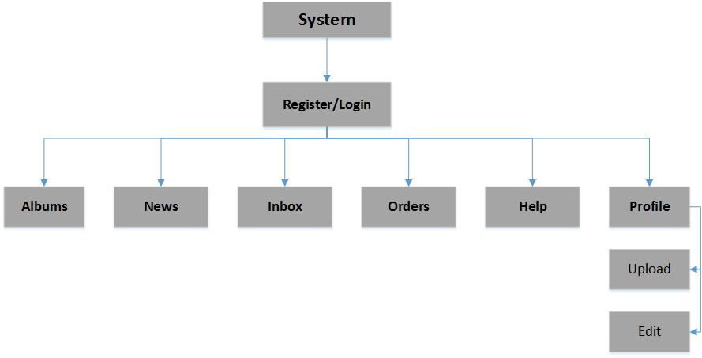Figure 1.1 Architecture Diagram for MUA

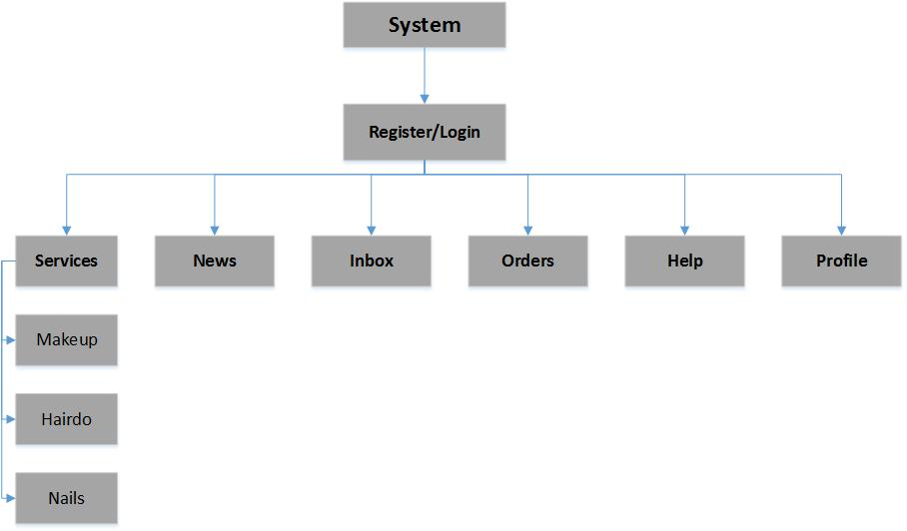

Figure 1.2 Architecture Diagram for Customer

## 1.7 Project Aims and Objectives

The aim of BeautéPanda is to create a market place where people who are self-employed as makeup artist can offer their services and make themselves known to the customer. This application is also for beauty salons that have already had physical building for their business, but want to reach more customers by offering their services through this application. We also want to help customer finding the perfect makeup/hairdo/nails for any occasion, contact the seller and make an appointment, all from one application. Other than that, this application is also intended to give users information about beauty – related news.

There are several objectives that we should set to achieve our project aim, which are:

* Facilitate user (as customer) to search for a makeup artist or salon that offer the service he/she needs
* Facilitate user (as sellers) to offer their service and reach the customer
* Assist customer and seller to chat each other to make an appointment and confirm the order
* Provide a reminder feature so that both users will not forget about an appointment
* Let administrator to manage content of the news section and help section

## 1.8 Project Scope

The result from this project will be an android application called BeautéPanda. There will be two types of user (customer and seller) and an administrator function to manage some contents of the application. The main purpose of our project is to facilitate sellers to offer their services and make it easier for customers to find makeup artist or beauty salon.

The scope of our project is listed below:

* Makeup artists or beauty salons can sign up as seller to offer their services and regular people can sign up as customer.
* The sellers will be able to upload photos of their makeup creations and put description and price range for the service.
* The customer will be able to select service from three categories, which are makeup, hairdo and nails. Each category will have its own specific categories, for example for makeup, the specific categories will be bridal, character, party and graduation.
* After selecting the desired service from specific category, customer will see list of sellers that offer that type of service.
* The customer will be able to send personal message to the seller and they can discuss about the service.
* If the seller and customer have discussed and agreed for a service, the seller will be able to make an appointment using the confirmation feature of this application and customer should confirm the appointment.
* This project will not handle the payment of any transaction, because the payment is done directly between customer and seller when they meet and after the service has been delivered.
* When both parties have confirmed, the service will go to order list and the application will send notification 24 hours and 2 hours before the transaction.
* The admin will be able to upload news or information about beauty trends and manage content in the help feature

## 1.9 Software and Hardware Requirements

|  |  |  |  |  |
| --- | --- | --- | --- | --- |
| **No** | **Item** | **Usage** | **Qty.** | **Cost** |
| Hardware | | | | |
| 1 | ASUS laptop X450J series | Project development | 1 | Available |
| 2 | Apple MacBook Pro Mid 2012 | Project development | 1 | Available |
| 3 | Samsung Galaxy A5 | Project testing | 1 | Available |
| 4 | Epson L210 printer | Document printing | 1 | Available |
| Operating system | | | | |
| 5 | Windows 10 | Project development | - | Available |
| 6 | MacOS Sierra 10.12.3 | Project development | - | Available |
| 7 | Android Nougat 7.0 | Project testing | - | Available |
| Others | | | | |
| 8 | IntelliJ IDEA Community Edition 2018.2.4 | Android application development | - | Available |
| 9 | Adobe Photoshop CS6 | User interface design | - | Available |
| 10 | Microsoft Visio Pro 2013 | Drawing UML diagrams | - | Available |
| 11 | Gantt Project 2.8.5 | Creating project schedule | - | Available |
| 12 | Microsoft Office Word 2013 | Creating project document | - | Available |
| 13 | Microsoft Office PowerPoint 2013 | Creating presentation for the project | - | Available |
| **Estimated Project Cost** | | | | Rupiah 0,- |

Table 1.1 Software and Hardware Requirements

## 1.10 Development Methodology

The methodology that we will use for our project is Agile Methodology. This method has four core values which we view to be suitable in developing a mobile application in this digital and ever – changing era. These values are: individuals and interactions over processes and tools, working software over comprehensive documentation, customer collaboration over contract negotiation and responding to change over following a plan (Cockburn, 2002).

The core of agile software development methods can be defined as the use of light-but-sufficient rules of project behaviour and the use of human- and communication-oriented rules. The agile process is both light and sufficient. Lightness is a means of remaining manoeuvrable. Sufficiency is a matter of staying in the game (Cockburn, 2002).

We choose Agile Methodology because it is a continuous cycle of improvement. Moreover, it focuses on communication between developers and users, and let the users participate in developing the application. This is better than the traditional development methodology because developer and user relation is not limited on the contract paper. This allows changes or additions to the application to meet the needs of users. We can have better understanding of the user and create our application to be as close as possible to what the users need.

# CHAPTER 2: PROJECT MANAGEMENT PLAN

## 2.1 Introduction

Project management plan is an important aspect in any type of project. The purpose of this plan is to help project team members have a clear understanding on what tasks should be carried out to achieve the project end goals, who should do it and when it should be done. Tasks and milestones are set in the beginning so that project members will know what is expected to finish the project.

Our project management plan starts from September until December 2018, which has been determined by the university. We have around 14 weeks to finish this BIT304 Final Project 1. Having project management plan will assist us in finishing the documents and codes for our applications within the time given, and to avoid the project not finish on the ending due date.

## 2.2 Work Item List

|  |  |  |  |
| --- | --- | --- | --- |
| **Name / Description** | **Priority** | **Assigned To** | **Effort estimated (days)** |
| **Initiating** |  |  |  |
| Initial Meeting with Supervisor | High | Niya and Lovely | 1 |
| Project Theme Identification | High | Niya and Lovely | 1 |
| Supervisor Consultation | High | Niya and Lovely | 1 |
| Project Theme Decision | High |  | 0 |
| **Planning** |  |  |  |
| Develop Project Background | High | Niya | 2 |
| Develop Project Aims and Objectives | High | Lovely | 2 |
| Develop Work Item List | Medium | Lovely | 1 |
| Develop Project Schedule | Medium | Niya | 1 |
| Select Software Methodology | Medium | Niya and Lovely | 1 |
| Develop Resource Plan | Medium | Lovely | 1 |
| Develop Risk Management Plan | High | Lovely | 1 |
| Submission of Project Plan | High |  | 0 |
| Submission of Project Management Plan | High |  | 0 |
| **Executing** |  |  |  |
| Gathering Requirements | High | Niya and Lovely | 4 |
| Develop Literature Review | High | Niya and Lovely | 5 |
| Literature Review Submission | High |  | 0 |
| Prepare for Interim Presentation | Medium | Niya and Lovely | 9 |
| Interim Presentation | High |  | 0 |
| Develop Requirement Analysis | High | Niya | 3 |
| Develop Functional & Non-Functional Requirement | High | Lovely | 4 |
| Develop Use Case Diagram | Medium | Niya and Lovely | 2 |
| Chapter 3 Submission | High |  | 0 |
| Develop Analysis Class Diagram | High | Niya and Lovely | 1 |
| Develop Sequence Diagram | High | Niya and Lovely | 1 |
| Database Design | Medium | Niya | 1 |
| Structural Design | Medium | Lovely | 1 |
| User Interface Design | High | Niya | 4 |
| **Construction** |  |  |  |
| Coding for Prototype | High | Niya and Lovely | 3 |
| Testing | High | Niya and Lovely | 1 |
| Chapter 4 Submission | High |  | 0 |
| **Closing** |  |  |  |
| Develop Progress Report | High | Niya and Lovely | 6 |
| Prepare Final Documentation | High | Niya and Lovely | 3 |
| Final Report Submission | High |  | 0 |
| Final Presentation Preparation | High | Niya and Lovely | 4 |
| Final Presentation | High |  | 0 |

Table 2.1 Work Item List

## 2.3 Work Breakdown Structure

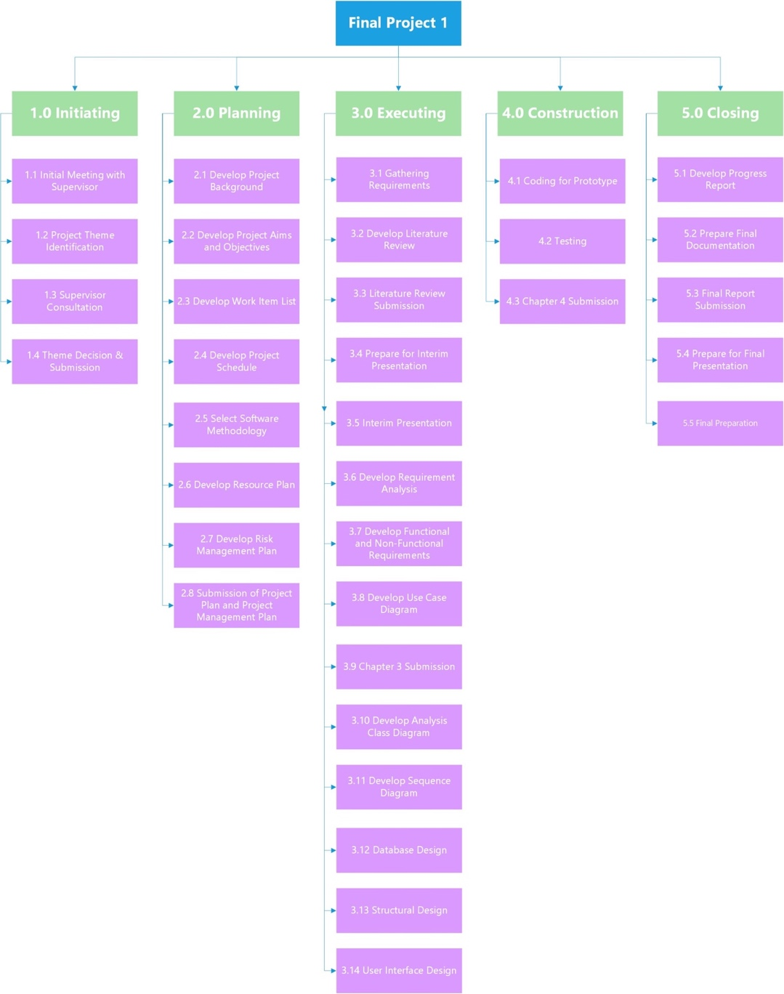

Figure 2.1 Work Breakdown Structure

|  |  |  |  |  |
| --- | --- | --- | --- | --- |
| Phases and Activities | Start Date | End Date | Duration in Days | Number of Resources (hours) |
| 1. **Initiating**    1. Initial Meeting with Supervisor    2. Project Theme Identification    3. Supervisor Consultation    4. Theme Decision & Submission | 9/28/2018  10/1/2018  10/2/2018  10/3/2018 | 9/28/2018  10/1/2018  10/2/2018  10/3/2018 | 1  1  1  0 | 3  9  2  5 |
| 1. **Planning**    1. Develop Project Background    2. Develop Project Aims and Objectives    3. Develop Work Item List    4. Develop Project Schedule    5. Select Software Methodology    6. Develop Resource Plan    7. Develop Risk Management Plan    8. Submission of Project Plan    9. Submission of Project Management Plan | 10/3/2018  10/5/2018  10/9/2018  10/10/2018  10/11/2018  10/11/2018  10/11/2018  10/12/2018  10/26/2018 | 10/4/2018  10/8/2018  10/9/2018  10/10/2018  10/11/2018  10/11/2018  10/11/2018  10/12/2018  10/26/2018 | 2  2  1  1  1  1  1  0  0 | 9  5  10  4  6  5  5  0  0 |
| 1. **Executing**    1. Gathering Requirements    2. Develop Literature Review    3. Literature Review Submission    4. Prepare for Interim Presentation    5. Interim Presentation    6. Develop Requirement Analysis    7. Develop Functional & Non-Functional Requirement    8. Develop Use Case Diagram    9. Chapter 3 Submission    10. Develop Analysis   Class Diagram   * 1. Develop Sequence   Diagram   * 1. Database Design   2. Structural Design   3. User Interface   Design | 10/15/2018  10/19/2018  10/26/2018  10/29/2018  11/9/2018  11/12/2018  11/15/2018  11/21/2018  11/23/2018  11/26/2018  11/26/2018  11/27/2018  11/27/2018  11/28/2018 | 10/18/2018  10/25/2018  10/26/2018  10/8/2018  11/9/2018  11/14/2018  11/20/2018  11/22/2018  11/23/2018  11/26/2018  11/26/2018  11/27/2018  11/27/2018  11/28/2018 | 4  5  0  9  0  3  4  2  0  1  1  1  1  4 | 9  12  0  6  0  8  7  8  0  6  6  6  6  12 |
| 1. **Construction**    1. Coding for Prototype    2. Testing    3. Chapter 4 Submission | 12/4/2018  12/4/2018  12/7/2018 | 12/6/2018  12/4/2018  12/7/2018 | 3  1  0 | 12  12  0 |
| 1. **Closing**    1. Develop Progress Report    2. Prepare Final Documentation    3. Final Report Submission    4. Prepare for Final Presentation    5. Final Presentation | 12/10/2018  12/18/2018  12/21/2018  12/24/2018  12/28/2018 | 12/17/2018  12/20/2018  12/21/2018  12/24/2018  12/28/2018 | 6  3  0  4  0 | 5  8  0  8  0 |

Table 2.2 Work Breakdown Structure

## 2.4 Risks Management

Every activity that is related to business will have some risks to certain extent. These risks must be analyzed and mitigation plan should be provided to overcome the risks. To deal with the risks that might occur in our project, we have identified potential risks, assessed and analyzed them, and we will be monitoring them until the project is done.

|  |  |  |  |
| --- | --- | --- | --- |
| **Risk** | **Potential Impact on Project Success**  **L/M/H** | **Likelihood of Occurrence**  **L/M/H** | **Mitigation Plan** |
| Lacking the skills and knowledge to develop a wholesome android application | H | H | Find online sources to learn how to properly develop android application and find an expert to consult or to give guidance |
| The application produced will have many bugs | H | M | Run unit and integration testing to the codes to find bugs, and run system testing when the application prototype has been created |
| Project is not finished within project period | H | M | Regularly hold meetings between project members so that the project is not neglected |
| Not being able to produce proper UML diagram to show the workflow of the application | M | M | Revise previous lecture notes for creating UML diagram and consult with the project supervisor to give corrections to the diagram |
| Loss of data due to virus infection | H | L | Regularly make a backup for all the files related to the project |

Table 2.3 Risks Management

## 2.5 Gantt Chart

This is our Gantt chart for this project. It starts on 28th September 2018 which is the first meeting with the supervisor where we propose our idea for this project. The project duration will be around 14 weeks, which will end on 28th December 2018 with final presentation for this BIT304 course. We use GanttProject to create the chart because it has great features and it is open source.

By creating a Gantt chart for this project, we can assign which member is responsible for a task and the duration for that task. We can also compare the project schedule with the actual duration taken to finish a task, and identify the critical path of the project where slacking cannot happen. This will help us to identify which tasks should be prioritized.

In our Gantt chart, we have several milestones which are: deciding project theme, submitting project plan, submitting project management plan, submitting literature review, interim presentation, submitting chapter 3 and 4, submitting final report and do the final presentation.

|  |  |  |
| --- | --- | --- |
| Milestones | Tasks | Estimation Completion Date |
| Project Theme Decision | Initiating | 3rd October 2018 |
| Submission of Project Plan | Planning | 12th October 2018 |
| Project Management Plan | Planning | 26th October 2018 |
| Literature Review Submission | Executing | 26th October 2018 |
| Interim Presentation | Executing | 9th November 2018 |
| Chapter 3 Submission | Executing | 23rd November 2018 |
| Chapter 4 Submission | Construction | 7th December 2018 |
| Final Report Submission | Closing | 21st December 2018 |
| Final Presentation | Closing | 28th December 2018 |

Table 2.4 Milestones

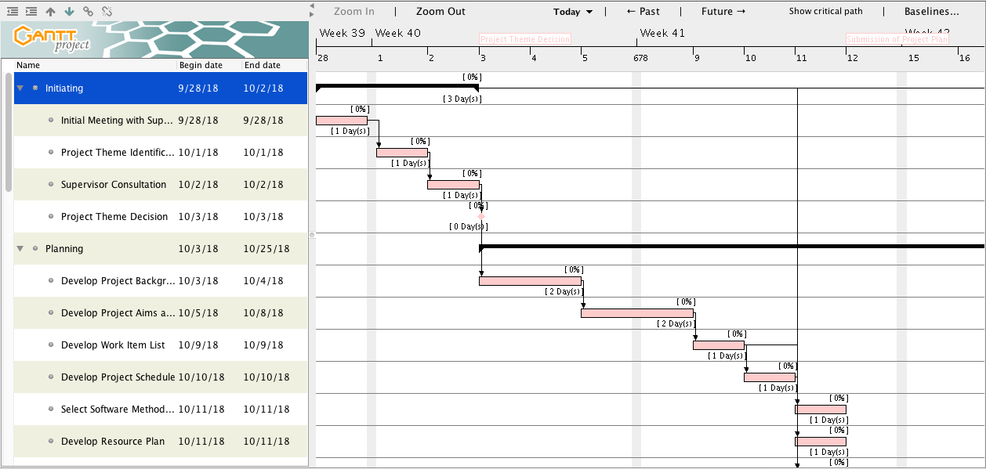

Figure 2.2 Gantt Chart (1)

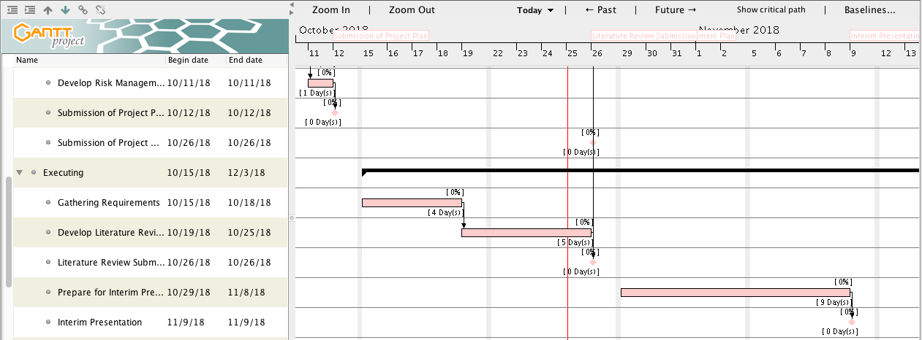

Figure 2.3 Gantt Chart (2)

# 

Figure 2.4 Gantt Chart (3)

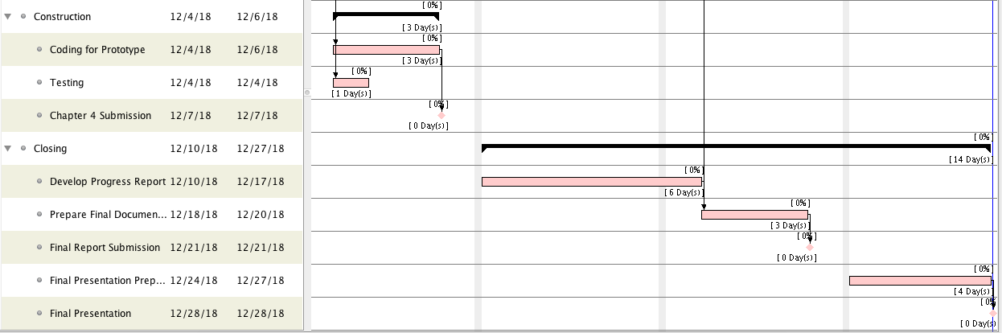

Figure 2.5 Gantt Chart (4)

# CHAPTER 3: REQUIREMENT ANALYSIS

## 3.1 Introduction

The requirement analysis is a major process in software engineering which provides an appropriate mechanism to understand what user wants from the system, analyse the user needs, assess eligibility of the system for the user, and so on (Moertini, Suhok, Heriyanto, & Nugroho, 2014). It is very important to make requirement analysis in developing a mobile application because it will help us as the developer to analyse what user needs from the system and meet those requirements so that the application we develop will be working as expected.

This chapter will discuss about the requirements summary which will be the summarization of all the requirements that are reflect accurately the details of the system. Beside, based on the system’s functions, requirements can be classified into functional and non-functional which in functional requirement, it will be specified all the prior function of the system and it describe what the system should do.

The function of the system also will be explained with a use case diagram, high-level use case, and expanded use case to describe in more details of the system’s function.In non-functional requirement, it is described how the system works, define the system properties or attributes and constraints from technical requirements to security requirements which it is very important while developing an application.

## 3.2 Requirements Summary

BeautéPanda is an android application for beauty enthusiasts. The main purpose of this application is to facilitate makeup artists and beauty salons to promote their service and to help customers to find them and contact them. The proposed application will have three users, which are makeup artists, customer and admin. Admin can post news about beauty trends, post announcements related to special promotions or events, and remove inappropriate feedback.

Makeup artist can create portfolio which includes information about their location and price, and photos of their makeup results. The application will also ask makeup artists to include some keywords that are suitable to describe their service, so that it will be easier for customer to search and find them. Moreover, makeup artists can view beauty news, make appointments with customer, reply feedback given by customer and reply direct message that are sent by customer.

Customer can search for makeup artists, view their portfolio and send message to them for more detailed information. They can also give rating and leave feedback for makeup artists whose service they have ordered. Additionally, customer can view beauty news and confirm to appointment that has been made by the makeup artist (which means they have agreed to meet so the service can be delivered). Last but not least, both customer and makeup artist can report feedback that is inappropriate e.g. racist, sexist, etc.

The functions in the application that are handled by the admin are:

* **Manage News:** admin can post, update or delete news about beauty trends
* **Manage Announcements:** admin can post, update or delete announcements about promotions or special events
* **Remove Feedback:** admin can delete feedback given by customer to makeup artist if it is inappropriate

The functions in the application that can be done by the makeup artists are:

* **Manage Portfolio:** makeup artist can post, update and delete information and photos about themselves to promote their service
* **Search and View Portfolio:** makeup artist can search and view the portfolio of other makeup artists
* **Reply Feedback:** makeup artist can reply feedback given by customers
* **Reply Message:** makeup artist can reply message sent by customers
* **View Beauty News:** view beauty-related news to increase their knowledge about beauty industry
* **Create Appointment:** after customer and makeup artist discuss about the service through messaging feature, and they have agreed to meet up, the makeup artist can create appointment which means the appointment will be officially recorded in the application. Some information should be included when creating the appointment, such as name of customer, agreed price, the meet-up time and place, and type of service to be delivered.
* **Report Feedback:** makeup artist can report the feedback given by customer if it is inappropriate.

The functions in the application that can be done by the customers are:

* **Search and View Portfolio:** customer can search for makeup artists and view their portfolio
* **Give Feedback:** customer can give feedback to makeup artist which service has been used
* **Give Rating:** customer can give rating to makeup artists which service has been used
* **Send Message:** customers can sent message to makeup artist to ask more information
* **View Beauty News:** view beauty-related news to increase their knowledge about beauty industry
* **Confirm to Appointment:** customer should confirm to appointment that have been created by makeup artists before the application officially record the appointment.
* **Report Feedback:** customer can report the feedback given by other customer if it is inappropriate.

## 3.3 Functional Requirements

The functions of the system are described in the functional requirements, which are:

1. **Register**

Makeup artists that want to offer their service using this application must register and provide basic information about themselves (name, date of birth, email address, username, password, email address, etc.).

Account verification will be done by sending email to the email address that is used to register and user has to confirm it.

After that, makeup artists can start using this application. For regular customer, they don’t have to register if they just want to view portfolio of the makeup artists and view beauty news. But if the customer wanted to send message, make appointment, give feedback and give rating, the customer has to be registered first.

1. **Login**

Both admin and users has to login with their account. But if the customer just wanted to view portfolio of the makeup artists and view beauty news, they don’t have to be logged in. There will special login process for admin because the functions being accessed are different from regular users. To log in, admin and both users has to enter their username or email address and password.

1. **Edit Profile**

This function will let both users to edit their profile.

1. **Edit Portfolio**

This function is only for makeup artist, which is for them to create, edit, and delete their portfolio.

1. **View Portfolio**

This function will let both users and admin to view portfolio of the makeup artist.

1. **Search for Makeup Artist**

This function will let both users and admin to search for makeup artist.

1. **Send Message**

This function is for customer to send message to the makeup artist.

1. **Reply Message**

This function is for makeup artist to reply the message that has been sent by customer.

1. **Make Appointment**

This function is for makeup artist to make appointment.

1. **Confirm Appointment**

This function is for customer to confirm the appointment that has been made by makeup artist.

1. **Give Feedback**

This function is for customer to give feedback to makeup artist which service has been used.

1. **Reply Feedback**

This function is for makeup artist to reply feedback given by customer.

1. **Give Rating**

This function is for customer to give rating to makeup artist which service has been used.

1. **Edit Beauty News**

This function is only admin, which is for them to post, edit, and delete beauty news.

1. **View Beauty News**

This function will let both users and admin to view beauty news.

1. **Edit Announcement**

This function is only for admin, which is for them to post, edit, and delete announcements.

1. **View Announcement**

This function will let both users and admin to view announcements.

1. **Report Feedback**

This function will allow users (customer and makeup artist) to report feedback that is inappropriate.

1. **Remove Feedback**

This function is only for admin, which is for them to remove inappropriate feedbacks.

1. **Logout**

This function will let both users and admin to logout of the system.

### 3.3.1 Use Case Diagram

**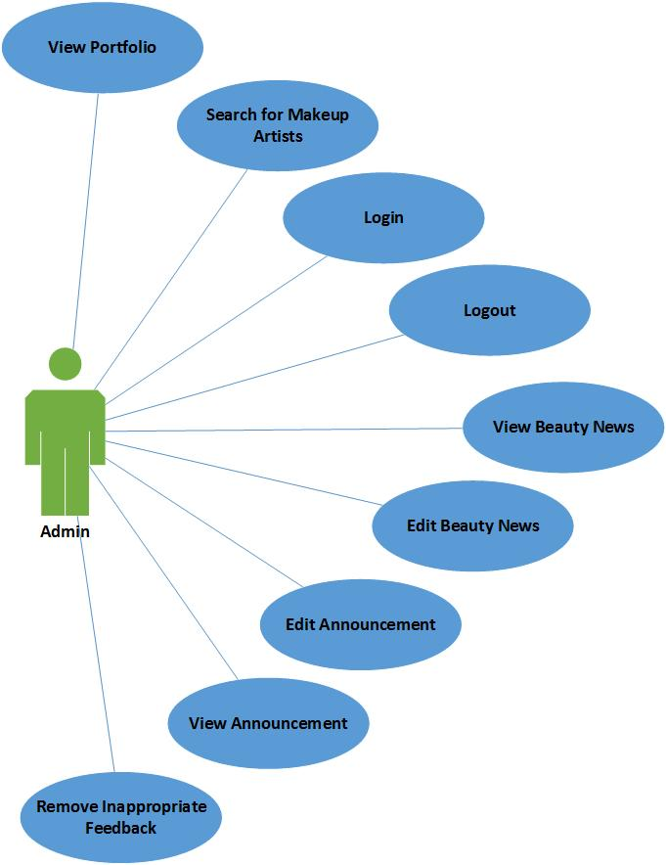**

Figure 3.1 Use Case for Admin

**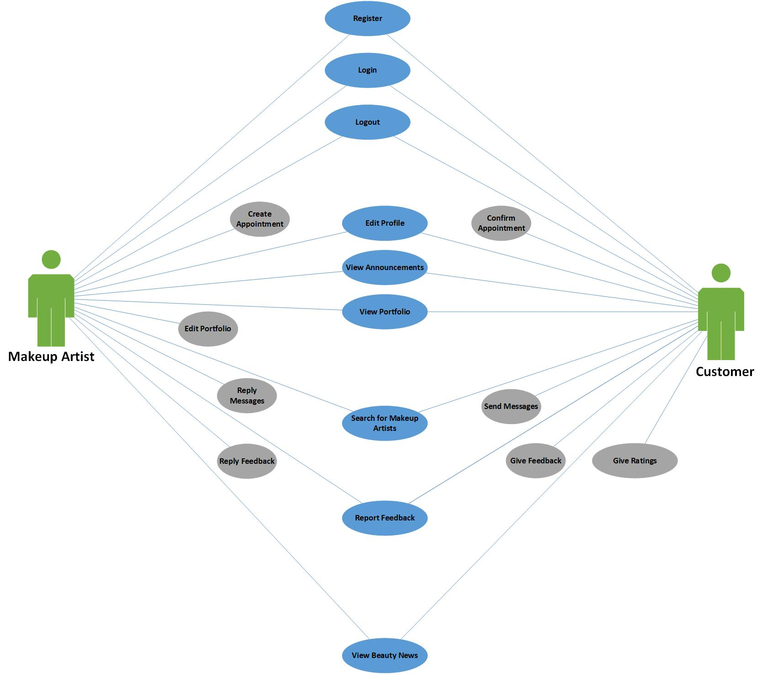**

Figure 3.2 Use Case for Customers

### 3.3.2 High – Level Use Case

|  |  |
| --- | --- |
| **Use Case** | Register |
| **Goal in Context** | User that has not yet registered can create an account |
| **Primary Actor**  **Secondary Actor** | User  - |
| **Description** | Unregistered user must provide their personal data to fill in the registration form and the newly created account must be verified with email. |

Table 3.1 High – Level Use Case: Register

|  |  |
| --- | --- |
| **Use Case** | Login |
| **Goal in Context** | User and admin can login to the application |
| **Primary Actor**  **Secondary Actor** | User and admin  - |
| **Description** | To login to the application, user and admin must provide their username or email address and password |

Table 3.2 High – Level Use Case: Login

|  |  |
| --- | --- |
| **Use Case** | Edit Profile |
| **Goal in Context** | User can edit their personal information that is entered in the application |
| **Primary Actor**  **Secondary Actor** | User  - |
| **Description** | User can edit profile picture, username, password, name, address, phone number, address, and birth of date. |

Table 3.3 High – Level Use Case: Edit Profile

|  |  |
| --- | --- |
| **Use Case** | Edit Portfolio |
| **Goal in Context** | User can edit their portfolio |
| **Primary Actor**  **Secondary Actor** | User  - |
| **Description** | User that is registered as makeup artist can fill their portfolio with photos and information that they want to display, and it can be edited as needed. |

Table 3.4 High – Level Use Case: Edit Portfolio

|  |  |
| --- | --- |
| **Use Case** | View Portfolio |
| **Goal in Context** | User and admin can see the portfolio of makeup artist that has registered to the application |
| **Primary Actor**  **Secondary Actor** | User and admin  - |
| **Description** | User and admin can select certain service (makeup or hairdo or nails), select a category (e.g. wedding or party), and the application will show a list of makeup artists. User can select a makeup artist to view the portfolio. |

Table 3.5 High – Level Use Case: View Portfolio

|  |  |
| --- | --- |
| **Use Case** | Search for Makeup Artist |
| **Goal in Context** | User and admin can search for specific makeup artist |
| **Primary Actor**  **Secondary Actor** | User and admin  - |
| **Description** | User and admin can search for specific service or makeup artist by entering a keyword in the search bar. |

Table 3.6 High – Level Use Case: Search for Makeup Artist

|  |  |
| --- | --- |
| **Use Case** | Send Message |
| **Goal in Context** | User can send message to makeup artist |
| **Primary Actor**  **Secondary Actor** | User  - |
| **Description** | User that is registered as customer can send message to makeup artist to ask for more detailed information. |

Table 3.7 High – Level Use Case: Send Message

|  |  |
| --- | --- |
| **Use Case** | Reply Message |
| **Goal in Context** | User can reply message from customer |
| **Primary Actor**  **Secondary Actor** | User  - |
| **Description** | User that is registered as makeup artist can reply message to customers to answer their questions. |

Table 3.8 High – Level Use Case: Reply Message

|  |  |
| --- | --- |
| **Use Case** | Make Appointment |
| **Goal in Context** | User can make an appointment with customer |
| **Primary Actor**  **Secondary Actor** | User  - |
| **Description** | User that is registered as makeup artist can make an appointment with customer by clicking ‘create appointment’ option and entering the time and place, the service to be delivered and the price. |

Table 3.9 High – Level Use Case: Make Appointment

|  |  |
| --- | --- |
| **Use Case** | Confirm Appointment |
| **Goal in Context** | User can confirm appointment to makeup artist. |
| **Primary Actor**  **Secondary Actor** | User  - |
| **Description** | User that is registered as customer can confirm the appointment that has been created by makeup artist. After the user has confirmed, the application will record the appointment as an order that is in progress for both users. |

Table 3.10 High – Level Use Case: Confirm Appointment

|  |  |
| --- | --- |
| **Use Case** | Give Feedback |
| **Goal in Context** | User can give feedback to makeup artist |
| **Primary Actor**  **Secondary Actor** | User  - |
| **Description** | User that is registered as customer can give feedback to makeup artist whose service has been used. |

Table 3.11 High – Level Use Case: Give Feedback

|  |  |
| --- | --- |
| **Use Case** | Reply Feedback |
| **Goal in Context** | User can reply feedback from customer |
| **Primary Actor**  **Secondary Actor** | User  - |
| **Description** | User that is registered as makeup artist can reply to feedbacks that are left by customers. |

Table 3.12 High – Level Use Case: Reply Feedback

|  |  |
| --- | --- |
| **Use Case** | Give Rating |
| **Goal in Context** | User can give rating to makeup artist |
| **Primary Actor**  **Secondary Actor** | User  - |
| **Description** | User that is registered as customer can give rating to makeup artist whose service has been used. |

Table 3.13 High – Level Use Case: Give Ratings

|  |  |
| --- | --- |
| **Use Case** | View Beauty News |
| **Goal in Context** | User and admin can view beauty related news |
| **Primary Actor**  **Secondary Actor** | User and admin  - |
| **Description** | User and admin can open news section to read the latest trends and news to increase their knowledge. |

Table 3.14 High – Level Use Case: View Beauty News

|  |  |
| --- | --- |
| **Use Case** | Edit Beauty News |
| **Goal in Context** | Admin can edit beauty news |
| **Primary Actor**  **Secondary Actor** | Admin  - |
| **Description** | Admin can add, update or delete beauty news which can be read by user. |

Table 3.15 High – Level Use Case: Edit Beauty News

|  |  |
| --- | --- |
| **Use Case** | View Announcement |
| **Goal in Context** | User and admin can view announcement |
| **Primary Actor**  **Secondary Actor** | User and admin  - |
| **Description** | User and admin can view announcement about special events or promotions. |

Table 3.16 High – Level Use Case: View Announcement

|  |  |
| --- | --- |
| **Use Case** | Report Feedback |
| **Goal in Context** | User can report inappropriate feedback |
| **Primary Actor**  **Secondary Actor** | User  - |
| **Description** | User can report feedbacks by customers which are inappropriate e.g. racist or sexist. |

Table 3.17 High – Level Use Case: Report Feedback

|  |  |
| --- | --- |
| **Use Case** | Edit Announcement |
| **Goal in Context** | Admin can edit announcement |
| **Primary Actor**  **Secondary Actor** | Admin  - |
| **Description** | Admin can add, update or delete announcement. |

Table 3.18 High – Level Use Case: Edit Announcement

|  |  |
| --- | --- |
| **Use Case** | Remove Feedback |
| **Goal in Context** | Admin can remove inappropriate feedback |
| **Primary Actor**  **Secondary Actor** | Admin  - |
| **Description** | Admin can remove feedbacks by customers which are inappropriate e.g. racist. |

Table 3.19 High – Level Use Case: Remove Feedback

|  |  |
| --- | --- |
| **Use Case** | Logout |
| **Goal in Context** | User and admin can logout from their account |
| **Primary Actor**  **Secondary Actor** | User and admin  - |
| **Description** | User and admin can logout from their account by selecting the logout button. |

Table 3.20 High – Level Use Case: Logout

### 3.3.3 Expanded Use Case

|  |  |
| --- | --- |
| **Use Case Name** | **Register** |
| **Goal in Context** | User that has not yet registered can create an account |
| **Primary Actor**  **Secondary Actor** | User  - |
| **Typical Course of Events** | |
| **Actor Action** | **System Response** |
| 1. This use case starts when a User clicks the register button | 1. The system will provide two options (customer or makeup artist) to choose from |
| 1. User choose to register as customer or makeup artist | 1. The system will display a registration form based on the user option |
| 1. User fill the registration form with their personal information | 1. System will run validation on the data being input |
|  | 1. A verification email will be sent by the system to the email address used in the registration form |
| 1. User has to open their email and click on the verification link to ensure that the email address used is truly theirs | 1. User account is saved to the database by the system after the verification process |
|  | 1. System will display the main menu which means registration has been successful |
| **Alternatives Course of Events** | |
| 1. A warning message will be displayed if one or more column in the registration form is not filled 2. A warning message will be displayed if the user input invalid email address 3. A warning message will be displayed if the password entered and password confirmation do not match 4. A warning message will be displayed if the password is less than 8 characters | |

Table 3.21 Expanded Use Case: Register

|  |  |
| --- | --- |
| **Use Case Name** | **Login** |
| **Goal in Context** | User and admin can login to the application |
| **Primary Actor**  **Secondary Actor** | User and admin  - |
| **Typical Course of Events** | |
| **Actor Action** | **System Response** |
| 1. This use case starts when a User or Admin clicks the login button | 1. The login form will be displayed by the system |
| 1. User or Admin has to fill out the login form with their username or email address and password |  |
| 1. User or Admin can click the login button after finish filling out the form | 1. System will check if the email address or username exist in the database and if the password match |
|  | 1. If the data entered are valid, the system will display the main menu |
| **Alternatives Course of Events** | |
| 1. If the email address or username does not exist in the database, a warning message will be displayed 2. If the inputted password is not correct, a warning message will be displayed | |

Table 3.22 Expanded Use Case: Login

|  |  |
| --- | --- |
| **Use Case Name** | **Edit Profile** |
| **Goal in Context** | User can edit their personal information that is entered in the application |
| **Primary Actor**  **Secondary Actor** | User  - |
| **Typical Course of Events** | |
| **Actor Action** | **System Response** |
| 1. This use case starts when a User chooses the profile menu | 1. The system will display the current information of the User |
| 1. User choose which information to edit and can click on pencil icon to edit | 1. The system will allow User to edit the selected information |
| 1. User update his/her personal information and click done when he/she has finished | 1. System will save the data that has been updated |
|  | 1. System will display message to notify User that changes have been saved |
| **Alternatives Course of Events** | |
| - | |

Table 3.23 Expanded Use Case: Edit Profile

|  |  |
| --- | --- |
| **Use Case Name** | **Edit Portfolio** |
| **Goal in Context** | User can edit their portfolio |
| **Primary Actor**  **Secondary Actor** | User  - |
| **Typical Course of Events** | |
| **Actor Action** | **System Response** |
| 1. This use case starts when a User that registered as a makeup artist open my portfolio page | 1. The system will display photos, videos or information that have been posted by the User |
|  | 1. The system will display add, edit and delete icons which User can choose from |
| 1. User chooses the action that he/she wants | 1. The system will allow User to add new information or edit or delete existing information |
| 1. User executes the action he/she wants and click done when he/she has finished | 1. The system will save the data that has been updated |
|  | 1. The system will display message to notify User that changes have been saved |
| **Alternatives Course of Events** | |
| 1. If the User has not posted anything yet, the page will be empty with message that nothing has been posted. | |

Table 3.24 Expanded Use Case: Edit Portfolio

|  |  |
| --- | --- |
| **Use Case Name** | **View Portfolio** |
| **Goal in Context** | User and admin can see the portfolio of makeup artist that has registered to the application |
| **Primary Actor**  **Secondary Actor** | User and admin  - |
| **Typical Course of Events** | |
| **Actor Action** | **System Response** |
| 1. This use case starts when a User and Admin open the home page | 1. The system will display three types of services, which are makeup, hairdo and nails |
| 1. User or Admin chooses the desired service | 1. The system will display the specific categories of the desired service |
| 1. User or Admin chooses the desired category | 1. The system will display list of makeup artist that is available to deliver the service |
| 1. User or Admin clicks on the profile of one makeup artist | 1. The system will display the portfolio of the selected makeup artist |
| **Alternatives Course of Events** | |
| - | |

Table 3.25 Expanded Use Case: View Portfolio

|  |  |
| --- | --- |
| **Use Case Name** | **Search for Makeup Artist** |
| **Goal in Context** | User and admin can search for specific makeup artist |
| **Primary Actor**  **Secondary Actor** | User and admin  - |
| **Typical Course of Events** | |
| **Actor Action** | **System Response** |
| 1. This use case starts when a User and Admin clicks on the search bar and enter what he/she is looking for |  |
| 1. User or Admin clicks the search icon | 1. The system will display the results that match with the keyword being searched |
| **Alternatives Course of Events** | |
| 1. If the keyword being entered does not match with any data in the database, the system will display message to notify User or Admin that no data is found | |

Table 3.26 Expanded Use Case: Search for Makeup Artist

|  |  |
| --- | --- |
| **Use Case Name** | **Send Message** |
| **Goal in Context** | User can send message to makeup artist |
| **Primary Actor**  **Secondary Actor** | User  - |
| **Typical Course of Events** | |
| **Actor Action** | **System Response** |
| 1. This use case starts when a User that registered as customer has selected a makeup artist and view his/her portfolio |  |
| 1. User selects message icon that appears when viewing the makeup artist portfolio | 1. The system will redirect the user to a chat room with the selected makeup artist as the recipient |
| 1. User types the message and can click send icon to send the message | 1. The system will send the message to the makeup artist |
| **Alternatives Course of Events** | |
| - | |

Table 3.27 Expanded Use Case: Send Message

|  |  |
| --- | --- |
| **Use Case Name** | **Reply Message** |
| **Goal in Context** | User can reply message from customer |
| **Primary Actor**  **Secondary Actor** | User  - |
| **Typical Course of Events** | |
| **Actor Action** | **System Response** |
| 1. This use case starts when a User that registered as makeup artist open the message menu | 1. The system will displayed the list of messages that have been sent by customers |
| 1. User can select a message that he/she wants to reply | 1. The system will display the content of the selected message |
| 1. User types message and can click send icon to reply the message | 1. The system will send the reply message to the customer |
| **Alternatives Course of Events** | |
| - | |

Table 3.28 Expanded Use Case: Reply Message

|  |  |
| --- | --- |
| **Use Case Name** | **Make Appointment** |
| **Goal in Context** | User can make an appointment with customer |
| **Primary Actor**  **Secondary Actor** | User  - |
| **Typical Course of Events** | |
| **Actor Action** | **System Response** |
| 1. This use case starts when a User that registered as makeup artist open the message menu | 1. The system will displayed the list of messages that have been sent by customers |
| 1. User can open a conversation with customer that want to make appointment | 1. The system will display the content of the selected message |
| 1. User can clicks add icon from the chat room to make an appointment | 1. The system will display a form for the user to fill the appointment details |
| 1. User can fill the details of the appointment |  |
| 1. User can click save icon to after filling out the form | 1. The system will check if the information being entered are valid |
|  | 1. The system will save the appointment and notify customer that the makeup artist has made an appointment with the customer and he/she has to confirm it |
| **Alternatives Course of Events** | |
| 1. If one of the columns in the form is empty, a warning message will be displayed | |

Table 3.29 Expanded Use Case: Make Appointment

|  |  |
| --- | --- |
| **Use Case Name** | **Confirm Appointment** |
| **Goal in Context** | User can confirm appointment to makeup artist. |
| **Primary Actor**  **Secondary Actor** | User  - |
| **Typical Course of Events** | |
| **Actor Action** | **System Response** |
| 1. This use case starts when a User that registered as customer receive notification that a makeup artist has made appointment with the User |  |
| 1. User clicks on the notification | 1. The system will display the message menu and open the conversation of the User with the makeup artist, and display the appointment and its details |
| 1. User can clicks on the appointment and read its details to make sure everything is correct |  |
| 1. User can clicks on the appointment and clicks on confirmation button | 1. The system will save the appointment with ‘confirmed status’ |
|  | 1. The system will send notification to makeup artist that the User has confirmed the order |
|  | 1. The system will put the appointment in ongoing order list for the User and makeup artist |
| **Alternatives Course of Events** | |
| - | |

Table 3.30 Expanded Use Case: Confirm Appointment

|  |  |
| --- | --- |
| **Use Case Name** | **Give Feedback** |
| **Goal in Context** | User can give feedback to makeup artist |
| **Primary Actor**  **Secondary Actor** | User  - |
| **Typical Course of Events** | |
| **Actor Action** | **System Response** |
| 1. This use case starts when a User that registered as customer has received the service from the makeup artist | 1. The system will send notification that the service has been delivered and the transaction is done |
| 1. User clicks on the notification | 1. The system will display the makeup artist that has done the service, a button for customer to give feedback and star icon to give rating |
| 1. User clicks on the give feedback button | 1. The system will display a textbox for User to type the feedback |
| 1. User fills the textbox with the feedback |  |
| 1. User can clicks on send button to submit the feedback | 1. The system will save the feedback and post it on the portfolio of the makeup artist |
|  | 1. The system will send notification to makeup artist that the User has left a feedback |
| **Alternatives Course of Events** | |
| - | |

Table 3.31 Expanded Use Case: Give Feedback

|  |  |
| --- | --- |
| **Use Case Name** | **Reply Feedback** |
| **Goal in Context** | User can reply feedback from customer |
| **Primary Actor**  **Secondary Actor** | User  - |
| **Typical Course of Events** | |
| **Actor Action** | **System Response** |
| 1. This use case starts when a User that registered as makeup artist receive a notification that a customer has given a feedback |  |
| 1. User clicks on the notification | 1. The system will display the feedback and reply button |
| 1. User clicks on the reply button | 1. The system will display a textbox for User to reply the feedback |
| 1. User fills the textbox with the reply |  |
| 1. User can clicks on send button to submit the reply | 1. The system will save the reply and post it under the feedback |
|  | 1. The system will send notification to customer that the User has replied to the feedback |
| **Alternatives Course of Events** | |
| - | |

Table 3.32 Expanded Use Case: Reply Feedback

|  |  |
| --- | --- |
| **Use Case Name** | **Give Rating** |
| **Goal in Context** | User can give rating to makeup artist |
| **Primary Actor**  **Secondary Actor** | User  - |
| **Typical Course of Events** | |
| **Actor Action** | **System Response** |
| 1. This use case starts when a User that registered as customer has received the service from the makeup artist | 1. The system will send notification that the service has been delivered and the transaction is done |
| 1. User clicks on the notification | 1. The system will display the makeup artist that has done the service, a button for customer to give feedback, and star icon to give rating |
| 1. User clicks on the star icon | 1. The system will display five empty stars |
| 1. User fills how many stars to give to the makeup artist based on quality of the service |  |
| 1. User can clicks on send button to submit the rating | 1. The system will save the rating and send notification to the makeup artist |
|  | 1. The system will display the average rating of the makeup artist on his/her portfolio |
| **Alternatives Course of Events** | |
| - | |

Table 3.33 Expanded Use Case: Give Ratings

|  |  |
| --- | --- |
| **Use Case Name** | **View Beauty News** |
| **Goal in Context** | User and admin can view beauty related news |
| **Primary Actor**  **Secondary Actor** | User and admin  - |
| **Typical Course of Events** | |
| **Actor Action** | **System Response** |
| 1. This use case starts when a User and Admin open the news page | 1. The system will display list of news that are related to beauty trends |
| 1. User or Admin clicks on the desired news to be read | 1. The system will open the news and display the article |
| **Alternatives Course of Events** | |
| 1. If no news has been posted yet, the page will be empty with message that nothing has been posted. | |

Table 3.34 Expanded Use Case: View Beauty News

|  |  |
| --- | --- |
| **Use Case Name** | **Edit Beauty News** |
| **Goal in Context** | Admin can edit beauty news |
| **Primary Actor**  **Secondary Actor** | Admin  - |
| **Typical Course of Events** | |
| **Actor Action** | **System Response** |
| 1. This use case starts when Admin open the news page | 1. The system will display list of news that are related to beauty trends |
|  | 1. The system will display add, edit and delete icons which Admin can choose from |
| 1. Admin chooses the action that he/she wants | 1. The system will allow Admin to add new news or edit or delete existing news |
| 1. Admin executes the action he/she wants and click done when he/she has finished | 1. The system will save the data that has been updated |
|  | 1. The system will display message to notify Admin that changes have been saved |
| **Alternatives Course of Events** | |
| 1. If no news has been posted yet, the page will be empty with message that nothing has been posted. | |

Table 3.35 Expanded Use Case: Edit Beauty News

|  |  |
| --- | --- |
| **Use Case Name** | **View Announcement** |
| **Goal in Context** | User and admin can view announcement |
| **Primary Actor**  **Secondary Actor** | User and admin  - |
| **Typical Course of Events** | |
| **Actor Action** | **System Response** |
| 1. This use case starts when User and Admin open the home page and scroll down to announcement section | 1. The system will display list of announcements related to special events or promotions |
| 1. User or Admin clicks on the desired announcement to be read | 1. The system will open the announcement and display the details |
| **Alternatives Course of Events** | |
| 1. If currently there is no announcement, the page will be empty with message that there is no new announcement. | |

Table 3.36 Expanded Use Case: View Announcement

|  |  |
| --- | --- |
| **Use Case Name** | **Edit Announcement** |
| **Goal in Context** | Admin can edit announcement |
| **Primary Actor**  **Secondary Actor** | Admin  - |
| **Typical Course of Events** | |
| **Actor Action** | **System Response** |
| 1. This use case starts when Admin open the home page and scroll down to announcement section | 1. The system will display list of announcements related to special events or promotions |
|  | 1. The system will display add, edit and delete icons which Admin can choose from |
| 1. Admin chooses the action that he/she wants | 1. The system will allow Admin to add new announcement or edit or delete existing announcement |
| 1. Admin executes the action he/she wants and click done when he/she has finished | 1. The system will save the data that has been updated |
|  | 1. The system will display message to notify Admin that changes have been saved |
| **Alternatives Course of Events** | |
| 1. If currently there is no announcement, the page will be empty with message that there is no new announcement. | |

Table 3.37 Expanded Use Case: Edit Announcement

|  |  |
| --- | --- |
| **Use Case Name** | **Report Feedback** |
| **Goal in Context** | User can report inappropriate feedback |
| **Primary Actor**  **Secondary Actor** | User  - |
| **Typical Course of Events** | |
| **Actor Action** | **System Response** |
| 1. This use case starts when User open a portfolio of a makeup artist and view the feedbacks |  |
| 1. User see an inappropriate feedback and he/she can select report option to report it | 1. The system will display message that asks User reason why he/she report the feedback |
| 1. User types in the reason why the feedback is inappropriate |  |
| 1. User selects submit button | 1. The system will display save the report and send it to admin to review it |
| **Alternatives Course of Events** | |
| - | |

Table 3.38 Expanded Use Case: Report Feedback

|  |  |
| --- | --- |
| **Use Case Name** | **Remove Feedback** |
| **Goal in Context** | Admin can remove inappropriate feedback |
| **Primary Actor**  **Secondary Actor** | Admin  - |
| **Typical Course of Events** | |
| **Actor Action** | **System Response** |
| 1. This use case starts when Admin open report page | 1. The system will display list of report from User |
| 1. Admin will review the reported feedback and see whether it is really inappropriate or not |  |
| 1. If the feedback is really inappropriate, admin can select it and click remove button | 1. The system will display message that feedback has been successfully removed |
| **Alternatives Course of Events** | |
| - | |

Table 3.39 Expanded Use Case: Remove Feedback

|  |  |
| --- | --- |
| **Use Case Name** | **Logout** |
| **Goal in Context** | User and admin can logout from their account |
| **Primary Actor**  **Secondary Actor** | User and admin  - |
| **Typical Course of Events** | |
| **Actor Action** | **System Response** |
| 1. The use case begins when User or Admin clicks the logout button from the home page | 1. The system will display message asking if the User or Admin really wants to log out |
| 1. User or Admin clicks the yes button | 1. The account will be logout from the application |
| **Alternatives Course of Events** | |
| 1. If User clicks no button, the display message will close and take the User back to his/her home page | |

Table 3.40 Expanded Use Case: Logout

## 3.4 Non – Functional Requirements

### 3.4.1 Technical Requirements

To develop and operate the mobile application, there are more than two technical requirements that required to be fulfilled. The mobile application will be met with all requirements. There are several technical requirements that need to be fulfilled as follows:

1. **Technical Requirements for The Application Developers**

In developing this mobile application, we decided to use IntelliJ IDEA as IDE. To operate IntelliJ IDEA properly, there are several requirements that need to be fulfilled.

* **Operating System (OS)**

IntelliJ IDEA can be installed in three Operating System such as Windows, Mac OS, and Linux. For Windows, it is required to use 32-bit or 64-bit and versions of Microsoft Windows of 10/8/7/Vista. For Mac OS, it is required to use Mac OS X 10.8.3 or higher versions and only 64-bit are supported to operate IntelliJ IDEA. However, for Linux it can be used in KDE, GNOME, or Unity desktop.

* **RAM**

It needs 2 GB RAM minimum to operate IntelliJ IDEA and it is recommended to use 4 GB RAM or higher to operate IntelliJ IDEA for better experience.

* **Screen Resolutions**

The minimum screen resolution that is requires to run the IntelliJ IDEA is 1024 x 768 pixels

* **Hard Drive Space**

The IntelliJ IDEA requires a minimum of 1.5 GB available for hard drive space in order to use the software properly. Also, it requires at least 1 GB for caches.

* **Java Development**

This software requires the developer to have a standalone JDK for Java development. However, The Java Runtime Environment (JRE) 1.8 is already bundled with IntelliJ IDEA distribution.

1. **Technical Requirements for The User**

To run and operate the mobile application, there are also some technical requirements for the user that need to be fulfilled. There are the technical requirements for the user as follows:

* **Operating System (OS)**

The user needs 5.1 Lollipop or higher versions of Android to run and operate this application on their smartphones.

* **RAM**

The minimum RAM of the smartphone that is required for the user to run and operate this application is 1 GB of RAM.

* **Screen Resolution**

The minimum screen size of the smartphone for the user to operate or run this application is 5 inch and minimum resolution is 1080 x 1920 pixels. For the aspect ratio is 16:9 which will be supported by this application.

### 3.4.2 Usability Requirements

It is very important to have a great experience of usability for a mobile application to fulfil the user’s desire and make the user feel satisfied so the user can operate the application properly and easily. The user interface is one of the aspects that is exist and it give big impact for usability of an application. To meet and fulfil the usability requirements, we decided to design our application’s user interface with Google’s Material Design.

The user interface design of this mobile application will be designed in simple way and attractive so the application can be understood by the user and the user can operate the application easily. For the icon, menu, image, and text that are exists in the application will be placed symmetrical in order to make the design looks presentable and well organized by the users.

A minimalist but attractive design will be appeared, so the user interface will look great and eyes catching. We also use a combination of pink, white, and grey for the colour of the user interface. Flat scheme of colour will be used because flat colour does not too flashy.

### 3.4.3 Reliability Requirements

The other requirements for a mobile application is reliability. The application must be reliable so the user can operate and use the application comfortably. To fulfil the requirements, the application must be accessible 24 hours and it be accessed everywhere so the user can access the application anytime they want.

All data in this application will be stored in database so to run this application, the user needs an internet connection to retrieve all data that are stored in the database. However, if the user has good internet connection but the application is not responding, the system will notify the user.

### 3.4.4 Security Requirements

The other important aspect for the mobile application is its security to make user feels safe in order of using the application. Because of those reason, access to the system is limited. The user must have an account first, if they want to contact or make appointment with the MUA or beauty salon so the user must register or sign up if they do not have an account or login if they already have an account.

Only admin can access the function that can modify the system such as update announcements, update beauty related news, update features in an application, and others. All communication between client and server will be secured and protected, also all data that are stored in the database will be encrypted to prevent unwanted things such as unauthorized access.

# CHAPTER 4: ITERATIONS

## 4.1 Introduction

In developing of the project, iteration is very important part to manage all the planning of project especially for the project that use Agile software development as the methodology. With the iteration plan, all the requirement that are needed to develop the project have the result as expected. Besides, the iteration in Agile methodology is a repeated interval work items that are fully developed and tested. Also, the iteration is needed to complete the project.

## 4.2 Iteration Plan

In this project, we develop our iteration plan to assure that our project is still on the track with our goal. In accordance with our project goals, we have to do many improvements and some changes in each phase to reach our goals. Therefore, we have to analyse the potential risk in each phase so we can eliminate and avoid the risks that may happen while developing this project and to assure all requirements in every phase is still in accordance with the requirements of this project.

### 4.2.1 Feasibility Study

## In feasibility study, we as developers have to determine whether the project is worth to do and to ensure it can actually be executed. To analyse the feasibility of the project, we have done some researches and ask potential customers what they think about the application. This is to make sure the customer is actually interested with our application and this project can be carried out. From this, we can plan the iterations which is suitable to customers’ needs.

## We have evaluated that our project is feasible to be done, as we have the resources to do it and we have learnt the programming language that is used in the project. Furthermore, we have made project schedule and see that this project is feasible from time point-of-view, which means we have enough time to develop this project.

### 4.2.2 Detailed Analysis

In detailed analysis phase, we defined between the functional and non – functional requirements that are needed to ensure the stability of application. In this analysis phase, the iteration plan will be conducted if the functional and non- functional requirements cannot fulfil the requirements that are needed in developing the project.

The iteration in this phase cannot be done until the functional and non – functional requirements can meet all the requirements that are needed for this project.

### 4.2.3 Designed Analysis

In the designed analysis phase, we illustrate the design of the system, interface design, and the workflow of the application. In this phase includes with high level and expanded use case, class diagram, sequence diagram, database design, and user interface design.

The iteration plan in this phase will be conducted if the design of the system is too complicated, for example the user interface is not friendly or there is something wrong with database. The iteration plan can be done by evaluating and checking all of the system design such as use case, class diagram, sequence diagram, database design, and user interface design until it can meet with all of the requirements that are needed.

### 4.2.4 Construction

The main focus of this phase is to make the application that correspond to the detailed design that has been illustrated. If there are some errors or there are functions that do not work properly, the iteration in construction phase will be conducted.

To solve these problems, the developers have to evaluate every prototype code until it works properly and match with the detailed design and detailed analysis that has been illustrated.

### 4.2.5 Testing

In this phase, we will check each phase in the system to make sure that the outcome of the system can meet all requirements and match with detailed design and detailed analysis. It also to check the system if there is no error. The iteration in testing phase will be used if there are still errors found in the system.

This phase uses validation and verification to ensure that the system correspond with the requirements that are needed for the project. We use validation to make sure that all requirements are met each other. Verification is also use to check each function.

### 4.2.6 System Delivery

The main focus of system delivery phase is to check the system whether it is already complete and meet all the requirements that are needed or not. This phase will be conducted, if there is any additional requirement need to be implemented in the system to make the system quality better.

### 4.2.7 Operation & Maintenance

This iteration plan will be used if there are some bugs that will interrupt the user while accessing the application. This iteration is needed to remove the bugs and make sure it will disappear and will not appear anymore in the future so the user will use the application comfortably.

This is the list of all use cases that are needed and it will be used for BeautéPanda application. It includes the schedule of iteration plan. In this Final Year Project 1, we have done the iteration of two use cases such as Register and Login.

|  |  |  |  |
| --- | --- | --- | --- |
| Iteration | Use Cases | Proposed Start Date | Proposed End Date |
| 1 | Register | 26th November 2018 | 30th November 2018 |
| 2 | Login | 3rd December 2018 | 6th December 2018 |
| 3 | Edit Profile | 4th February 2019 | 8th February 2019 |
| 4 | Edit Portfolio | 11th February 2019 | 15th February 2019 |
| 5 | View Portfolio | 11th February 2019 | 15th February 2019 |
| 6 | Search Makeup Artist or Beauty Salon | 18th February 2019 | 22nd February 2019 |
| 7 | Send Message | 25th February 2019 | 1st March 2019 |
| 8 | Reply Message | 25th February 2019 | 1st March 2019 |
| 9 | Make an Appointment | 4th March 2019 | 11th March 2019 |
| 10 | Confirm an Appointment | 4th March 2019 | 11th March 2019 |
| 11 | Give Feedback | 12th March 2019 | 15th March 2019 |
| 12 | Reply Feedback | 12th March 2019 | 15th March 2019 |
| 13 | Give Rating | 18th March 2019 | 22nd March 2019 |
| 14 | View Beauty News | 25th March 2019 | 29th March 2019 |
| 15 | Edit Beauty News | 25th March 2019 | 29th March 2019 |
| 16 | View Announcements | 1st April 2019 | 5th April 2019 |
| 17 | Report Feedback | 1st April 2019 | 5th April 2019 |
| 18 | Edit Announcements | 8th April 2019 | 12th April 2019 |
| 19 | Remove Feedback | 8th April 2019 | 12th April 2019 |
| 20 | Logout | 15th April 2019 | 19th April 2019 |

Table 4.1 Operation and Maintenance

## 4.3 Iteration 1

### 4.3.1 Introduction

In this Final Year Project 1, we have completed two prototypes of our application called BeautéPanda which are register page and login page. After we finished developing the prototypes, we started to check the prototypes by testing the prototypes. The schedule for this iteration plan began on November 26, 2018 to December 6, 2018 which has certain aims and goals. The aims and goals are follows:

* To ensure the function of register and login page are work properly and without any bugs or error that might be interrupted the user while using the application.
* To ensure the register and login page are working in accordance with detailed analysis
* To ensure the interface of register and login page met with detailed design which are user friendly and easy to use. Therefore, everyone can use this application properly.

### 4.3.2 Purpose

Iteration in developing a project is very important phase. Iteration itself contributes in overall development of this project. In feasibility study, iteration contributed to ensure the project met the required resources that are needed to build BeautéPanda application and also to ensure that this application can meet all the user requirements.

Besides, in detailed analysis and detailed design, iteration plan contributed to ensure the analysis and the design of the system can meet the requirements that are needed in developing the project and also to ensure that the user interface of the application is user friendly and easy to use by the user. For the construction, the iteration contributed to ensure that the application that we developed is in accordance with detailed analysis that has been illustrated.

In testing of the system, iteration contributed to ensure that the prototypes of the application can give the great outcomes as expected in detailed design and detailed analysis, also to ensure that the prototypes did not processed errors. While in system delivery, iteration contributed to ensure that the prototypes of the application is complete and resemble the real system.

In operation and maintenance, it contributed in checking the bugs to ensure that there is no interruption in the system. Nevertheless, we have not implemented the system delivery and operation and maintenance stage yet because it stage will be implemented and finished in Final Year Project 2 later.

### 4.3.3 Context

This iteration plan can meet with all the requirements of the project that are needed. Also, this iteration plan can speed up the process of developing this project and to ensure that our project is in accordance with the project goal that we expected. The first two use cases that will be developed in this iteration are register and login. The iteration for register use case is we want to make sure that we have done the analysis to ensure that the register page meets all the requirements that are needed and run properly. Besides, for login use case we make sure that can login page can work and run properly without any errors and interference. We also ensure that the overall user interface is user – friendly and user can use the application comfortably.

### 4.3.4 Schedule of Iteration Workflows

In implementing this iteration, there are no significant problems that might be interrupted the schedule of our project. Therefore, we can implement the iteration accordance to the project schedule so there is no delay in our schedule for iteration.

|  |  |  |  |
| --- | --- | --- | --- |
| Workflow | Start Date | End Date | Duration (days) |
| **Use Case 1: Register** |  |  |  |
| Analysis | 26th November 2018 | 30th November 2018 | 5 Days |
| Design | 26th November 2018 | 30th November 2018 | 5 Days |
| Implementation | 26th November 2018 | 30th November 2018 | 5 Days |
| Testing | 26th November 2018 | 30th November 2018 | 5 Days |
| **Use Case 2: Login** |  |  |  |
| Analysis | 3rd December 2018 | 6th December 2018 | 4 Days |
| Design | 3rd December 2018 | 6th December 2018 | 4 Days |
| Implementation | 3rd December 2018 | 6th December 2018 | 4 Days |
| Testing | 3rd December 2018 | 6th December 2018 | 4 Days |

Table 4.2 Schedule of Iteration Workflows

### 4.3.5 Iteration Schedule Breakdown

|  |  |  |  |
| --- | --- | --- | --- |
| Task Name | Start | Finish | Assigned To |
| Use Case 1 (Register) | 26th November 2018 | 30th November2018 | Lovely |
| **1.1 Analysis** |  |  |  |
| 1.1.1 Analysing of register requirement | 26th November 2018 | 30th November2018 | Lovely & Niya |
| * 1. **Design** |  |  |  |
| 1.1.2 Designing of the registration form and interface | 26th November 2018 | 30th November2018 | Niya |
| **1.3 Implementation** |  |  |  |
| 1.1.3 Implementation of registration | 26th November 2018 | 30th November2018 | Lovely |
| **1.4 Testing** |  |  |  |
| 1.1.4 Testing register | 26th November 2018 | 30th November2018 | Lovely & Niya |

Table 4.3 Iteration Schedule Breakdown for Register

|  |  |  |  |
| --- | --- | --- | --- |
| Task Name | Start | Finish | Assigned To |
| Use Case 2 (Login) | April 12, 2018 | April 13, 2018 | Niya |
| 1.1 Analysis |  |  |  |
| 1.1.1 Analysis of login requirement | April 12, 2018 | April 13, 2018 | Lovely & Niya |
| 1.2 Design |  |  |  |
| * 1. 2 Design of the login form and interface | April 12, 2018 | April 13, 2018 | Niya |
| 1.3 Implementation |  |  |  |
| 1.1.3 Implementation of login | April 12, 2018 | April 13, 2018 | Lovely |
| 1.4 Testing |  |  |  |
| 1.1.4 Testing login | April 12, 2018 | April 13, 2018 | Lovely & Niya |

Table 4.4 Iteration Schedule Breakdown for Login

### 4.3.6 Resource Summary

|  |  |  |  |  |
| --- | --- | --- | --- | --- |
| No | Resources | Usage | Quantity | Cost |
| **Hardware** | | | |  |
| 1 | Computer  ASUS laptop X450J  (Windows 10) | Project development of android application and testing with emulator | 1 computer | Rp 0  (Existing computer) |
| 2 | Samsung Galaxy A5  (Android Nougat 7.0) | Project testing to ensure the application can run properly | 1 smartphone | Rp 0  (Existing smartphone) |
| 3 | Computer  Apple MacBook Pro Mid 2012 | Project development of android application and testing with emulator | 1 computer | Rp 0  (Existing computer) |
| **Software** | | | |  |
| 4 | IntelliJ IDEA Community Edition 2018.2.4 | Android application development to develop the front – end and back – end of BeautéPanda | 2 platforms | Rp 0  (Open source) |
| **Human Resources** | | | |  |
| 5 | Team member | Developing and testing the prototype of the system | 2 members | Rp 0 |

Table 4.5 Resource Summary

### 4.3.7 Evaluation Criteria

We have successfully finished the iteration plan. We got more understanding with the application that we develop after we did the evaluation of the user requirements for this application. We have done this chapter 4 (Iteration) in time and no delays in our schedule that we made before. We also got more understanding about to use and operate the software that we used during develop the application.

### 4.3.8 Analysis and Design Artefact

#### 4.3.8.1 Analysis Artefact

##### 4.3.8.1.1 Analysis Class Diagram

**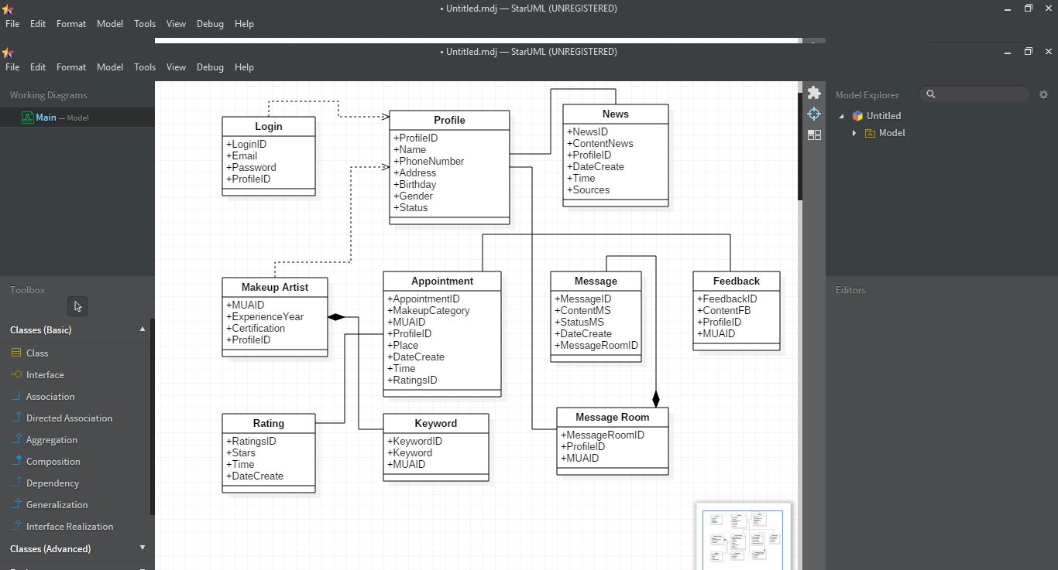**

Figure 4.1 Analysis Class Diagram

#### 4.3.8.2 Design Artefact

##### 4.3.8.2.1 Sequence Diagram

**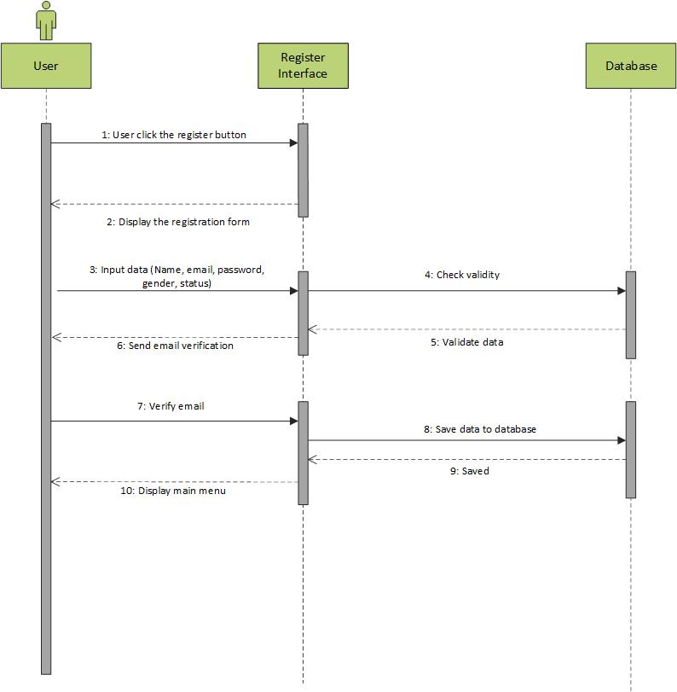**

Figure 4.2 Sequence Diagram of Register Interface

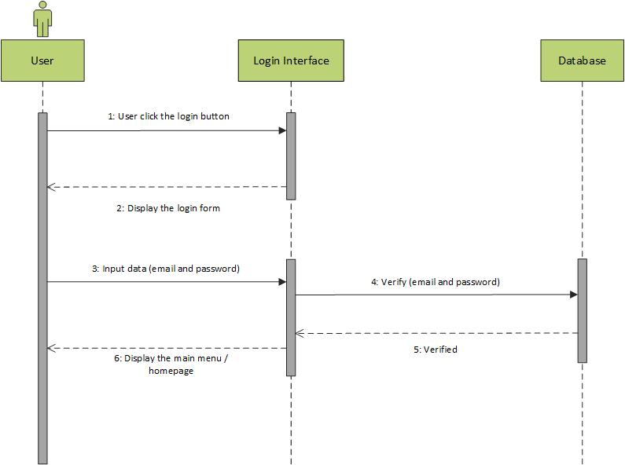

Figure 4.3 Sequence Diagram of Login Interface

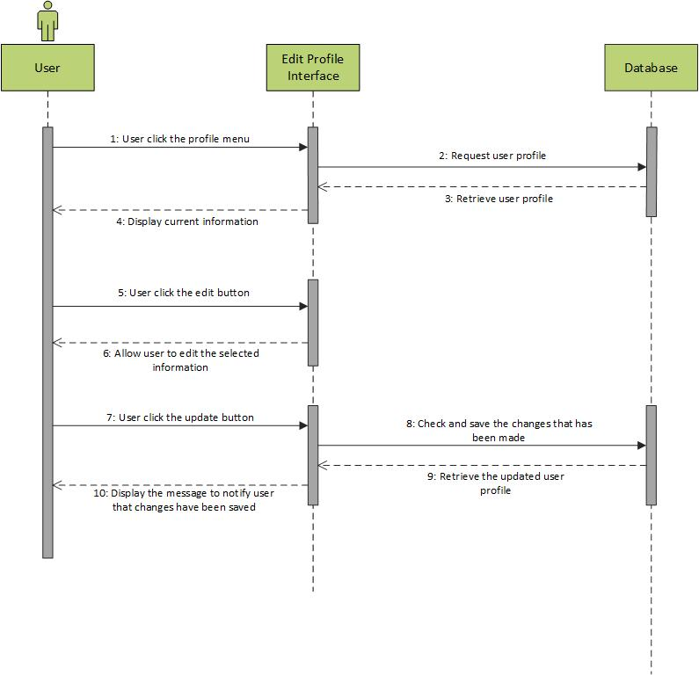

Figure 4.4 Sequence Diagram of Editing Profile Interface

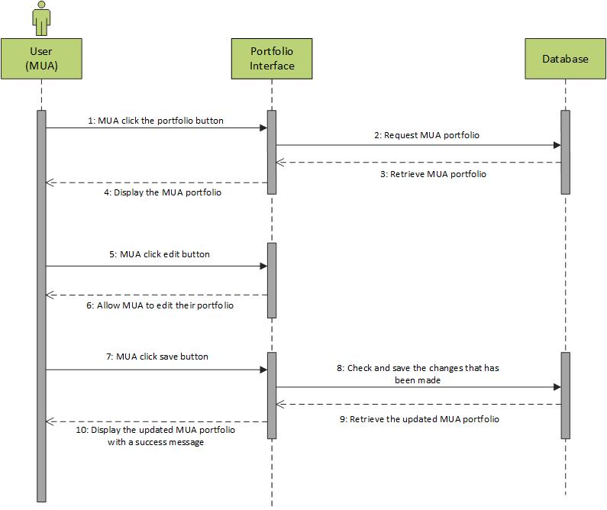

Figure 4.5 Sequence Diagram of Portfolio Interface (1)

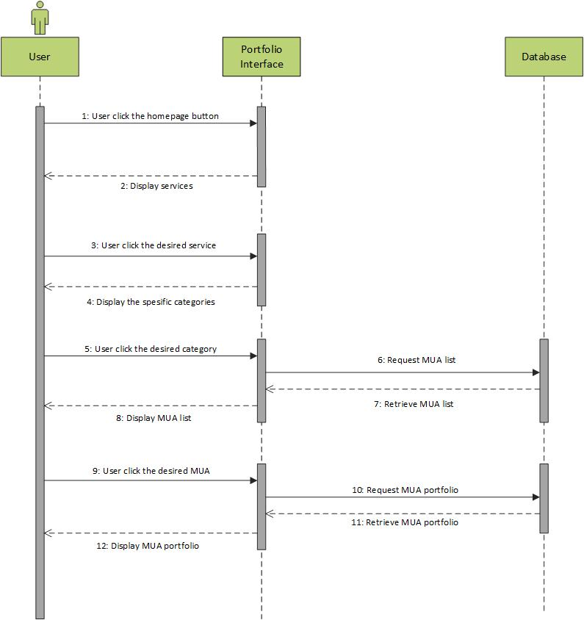

Figure 4.6 Sequence Diagram of Portfolio Interface (2)

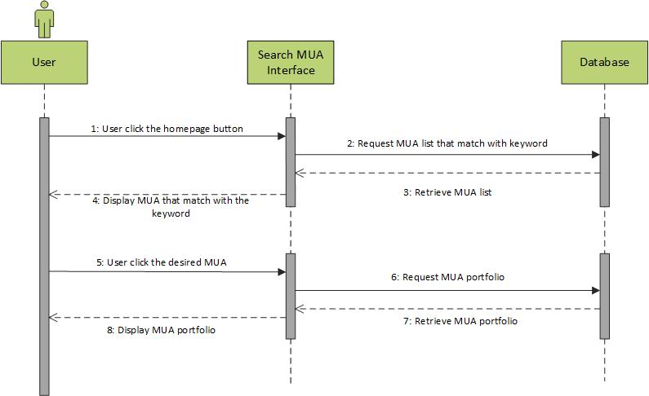

Figure 4.7 Sequence Diagram of Searching MUA Interface

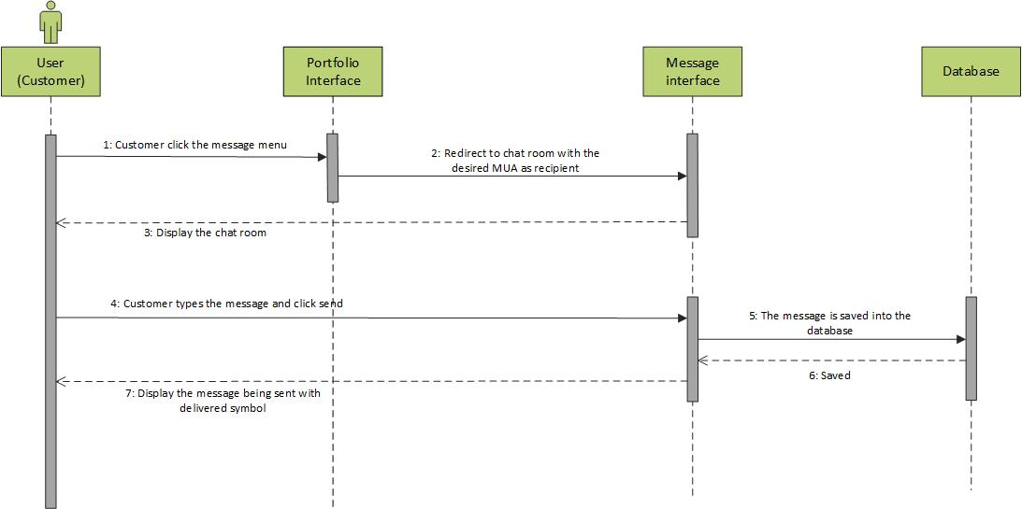

Figure 4.8 Sequence Diagram of Sending Message Interface

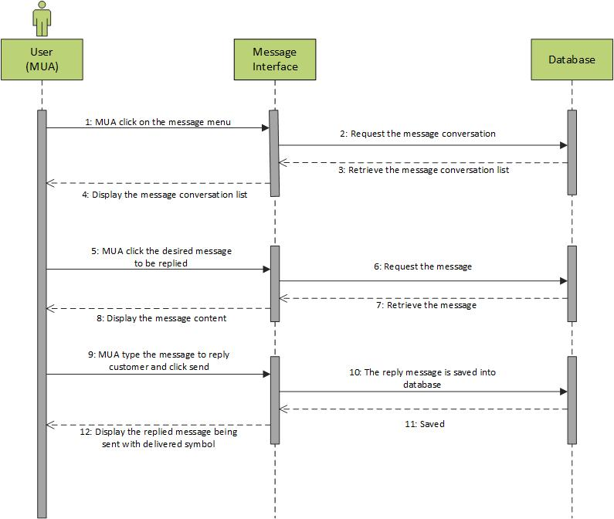

Figure 4.9 Sequence Diagram of Replying Message Interface

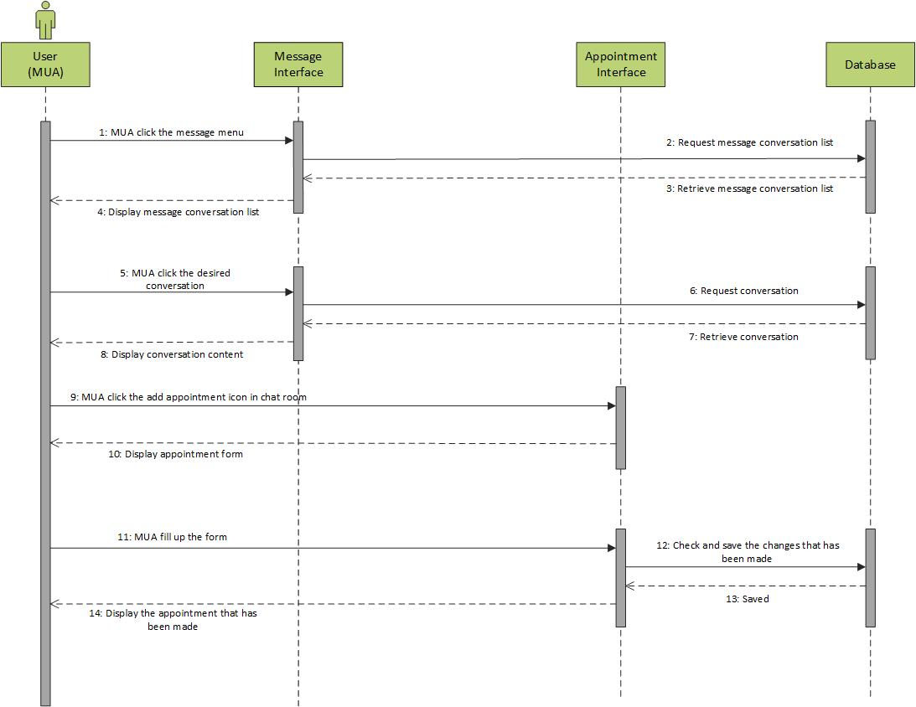

Figure 4.10 Sequence Diagram of Making Appointment Interface

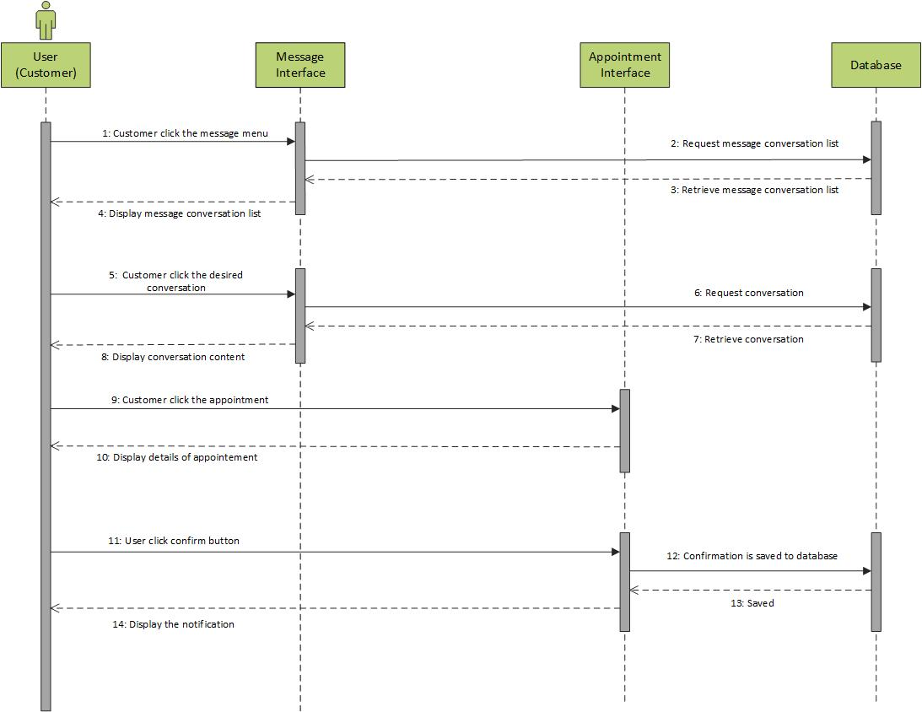

Figure 4.11 Sequence Diagram of Confirming Appointment Interface

**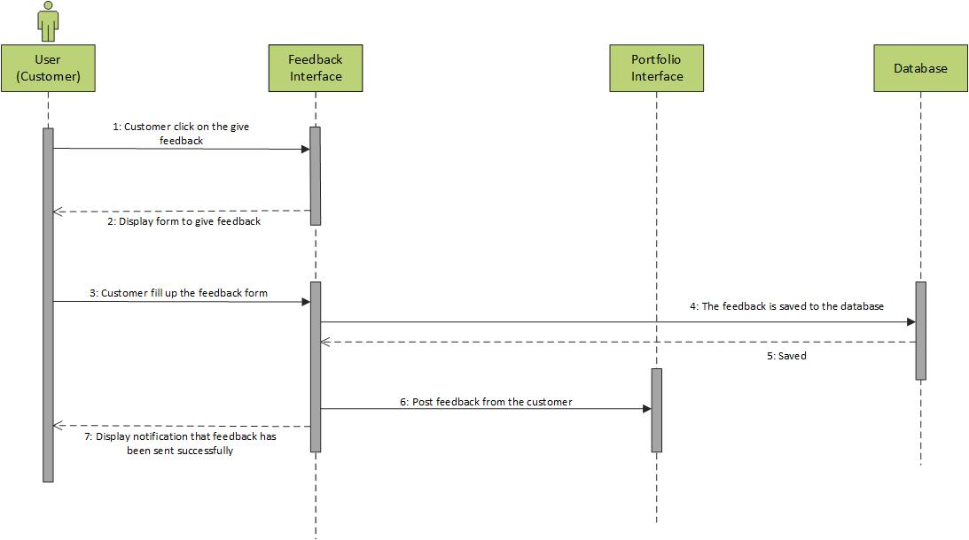**

Figure 4.12 Sequence Diagram of Giving Feedback Interface

**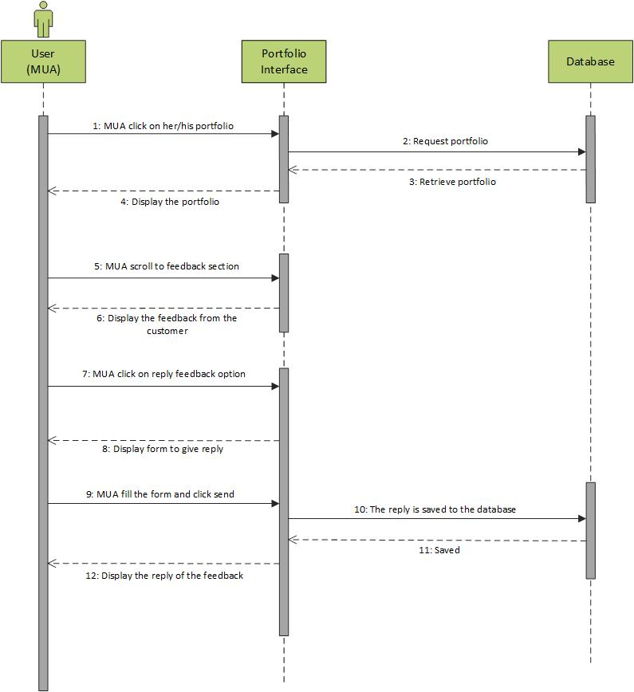**

Figure 4.13 Sequence Diagram of Replying Feedback Interface

**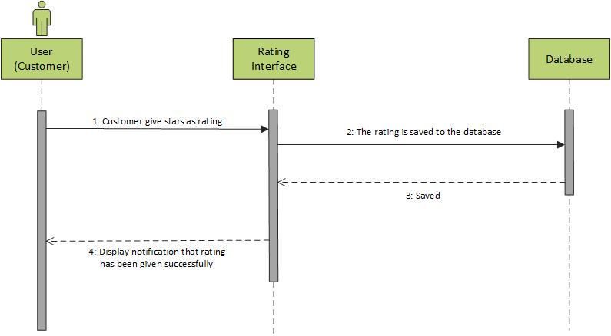**

Figure 4.14 Sequence Diagram of Giving Rating Interface

**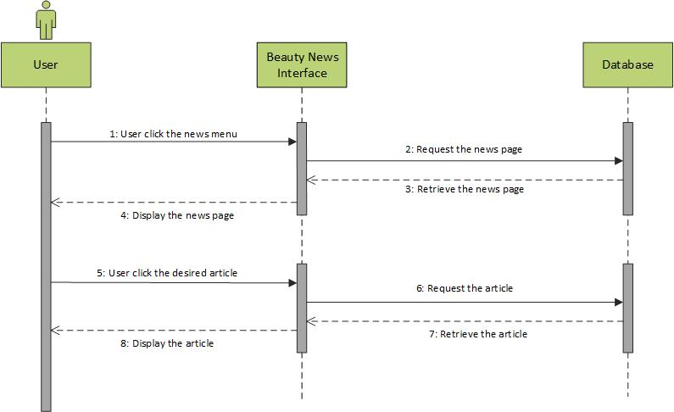**

Figure 4.15 Sequence Diagram of Viewing Beauty News Interface

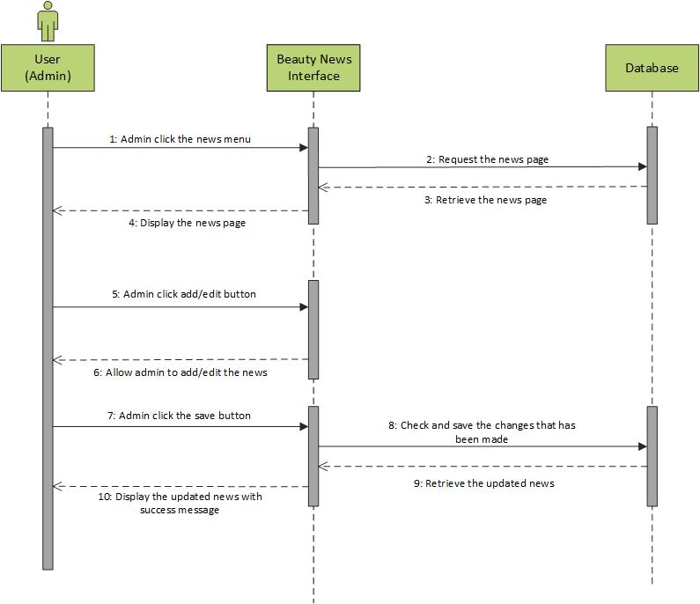

Figure 4.16 Sequence Diagram of Updating Beauty News Interface

**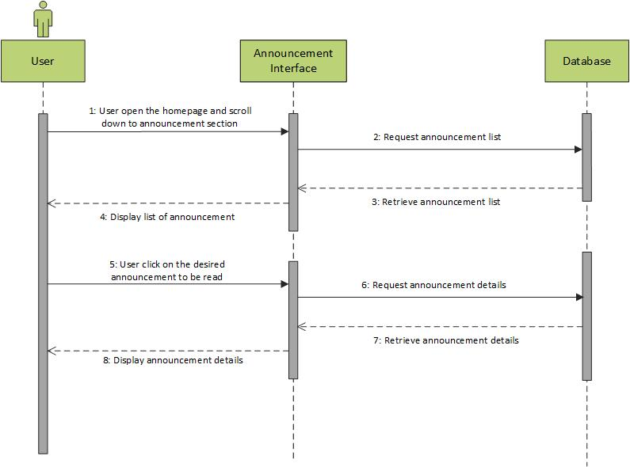**

Figure 4.17 Sequence Diagram of Viewing Announcement Interface

**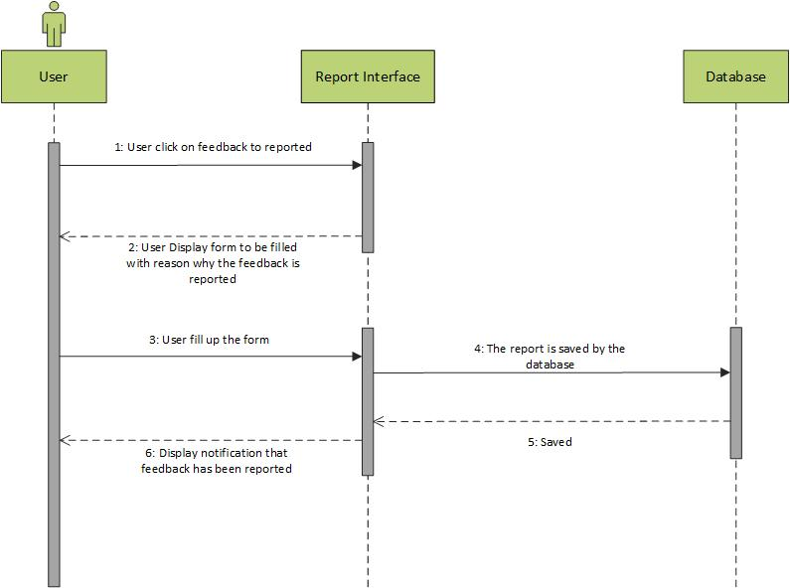**

Figure 4.18 Sequence Diagram of Reporting Feedback Interface

**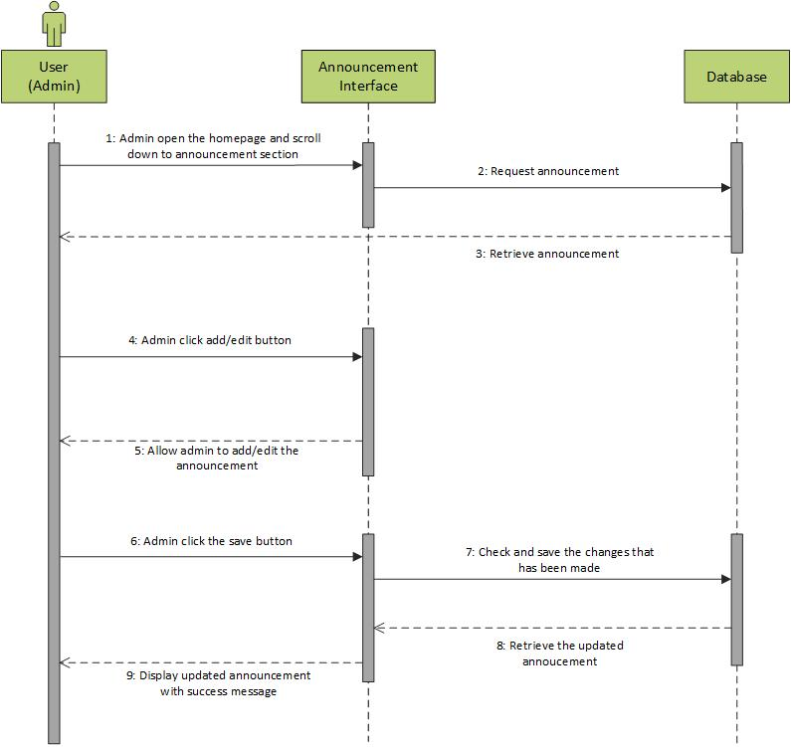**

Figure 4.19 Sequence Diagram of Updating Announcement Interface

**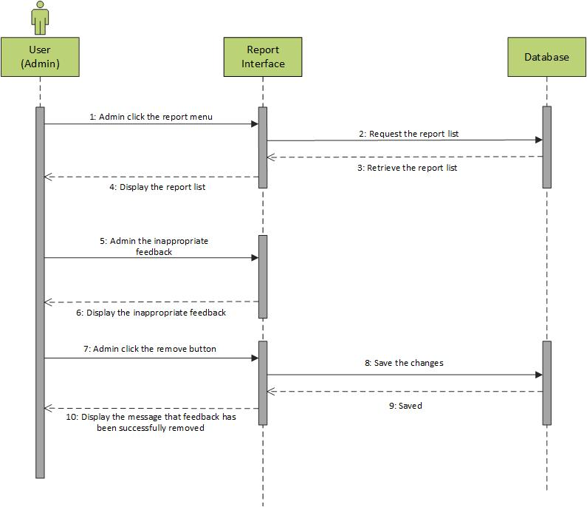**

Figure 4.20 Sequence Diagram of Removing Feedback Interface

**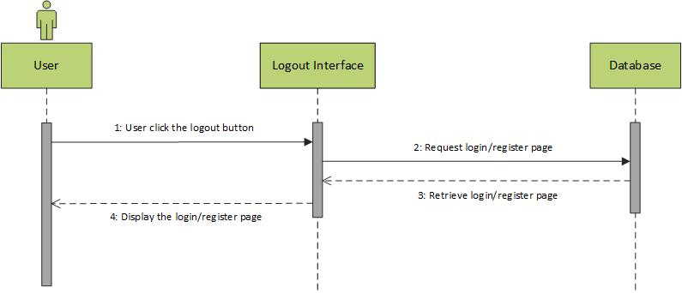**

Figure 4.21 Sequence Diagram of Logout Interface

##### 4.3.8.2.2 Database Design

|  |  |  |  |  |
| --- | --- | --- | --- | --- |
| Key | Column Name | Data Type | Allow Null | Length |
| PK | LoginID | Int | Yes | 15 |
|  | Email | Varchar | No | 30 |
|  | Password | Varchar | No | 30 |
|  | ProfileID | Int | No | 30 |

Table 4.6 Database Design of Login

|  |  |  |  |  |
| --- | --- | --- | --- | --- |
| Key | Column Name | Data Type | Allow Null | Length |
| PK | KeywordID | Int | Yes | 15 |
|  | Keyword | Varchar | No | 255 |
|  | MUAID | Int | No | 15 |

Table 4.7 Database Design of Keyword

|  |  |  |  |  |
| --- | --- | --- | --- | --- |
| Key | Column Name | Data Type | Allow Null | Length |
| PK | MUAID | Int | Yes | 15 |
|  | ExperienceYear | Year | No | - |
|  | Certification | Varchar | No | 255 |
|  | ProfileID | Int | No | 15 |

Table 4.8 Database Design of MUA

|  |  |  |  |  |
| --- | --- | --- | --- | --- |
| Key | Column Name | Data Type | Allow Null | Length |
| PK | AppointmentID | Int | Yes | 15 |
|  | MakeupCategory | Varchar | No | 255 |
|  | MUAID | Int | No | 15 |
|  | ProfileID | Int | No | 15 |
|  | Place | Varchar | No | 255 |
|  | DateCreate | Date | No | - |
|  | Time | Time | No | - |
|  | RatingID | Int | No | 15 |

Table 4.9 Database Design of Appointment

|  |  |  |  |  |
| --- | --- | --- | --- | --- |
| Key | Column Name | Data Type | Allow Null | Length |
| PK | ProfileID | Int | Yes | 15 |
|  | Name | Varchar | No | 255 |
|  | PhoneNumber | Varchar | No | 255 |
|  | Address | Varchar | No | 255 |
|  | Status | Int | No | 15 |
|  | Birthday | Date | No | - |
|  | Gender | Int | No | 15 |

Table 4.10 Database Design of Profile

|  |  |  |  |  |
| --- | --- | --- | --- | --- |
| Key | Column Name | Data Type | Allow Null | Length |
| PK | FeedbackID | Int | Yes | 15 |
|  | ContentFB | Text | No | - |
|  | ProfileID | Int | No | 15 |
|  | MUAID | Int | No | 15 |

Table 4.11 Database Design of Feedback

|  |  |  |  |  |
| --- | --- | --- | --- | --- |
| Key | Column Name | Data Type | Allow Null | Length |
| PK | MessageID | Int | Yes | 15 |
|  | ContentMS | Text | No | - |
|  | StatusMS | Varchar | No | 255 |
|  | DateCreate | Date | No | - |
|  | MessageRoomID | Int | No | 15 |

Table 4.12 Database Design of Message

|  |  |  |  |  |
| --- | --- | --- | --- | --- |
| Key | Column Name | Data Type | Allow Null | Length |
| PK | MessageRoomID | Int | Yes | 15 |
|  | ProfileID | Int | No | 15 |
|  | MUAID | Int | No | 15 |

Table 4.13 Database Design of Message Room

|  |  |  |  |  |
| --- | --- | --- | --- | --- |
| Key | Column Name | Data Type | Allow Null | Length |
| PK | NewsID | Int | Yes | 15 |
|  | ContentNews | Text | No | - |
|  | ProfileID | Int | No | 15 |
|  | DateCreate | Date | No | - |
|  | Time | Time | No | - |
|  | Sources | Varchar | No | 255 |

Table 4.14 Database Design of News

|  |  |  |  |  |
| --- | --- | --- | --- | --- |
| Key | Column Name | Data Type | Allow Null | Length |
| PK | RatingsID | Int | Yes | 15 |
|  | Stars | Int | No | 5 |
|  | Time | Time | No | - |
|  | DateCreate | Date | No | - |

Table 4.15 Database Design of Ratings

##### 4.3.8.2.3 Structural Design

**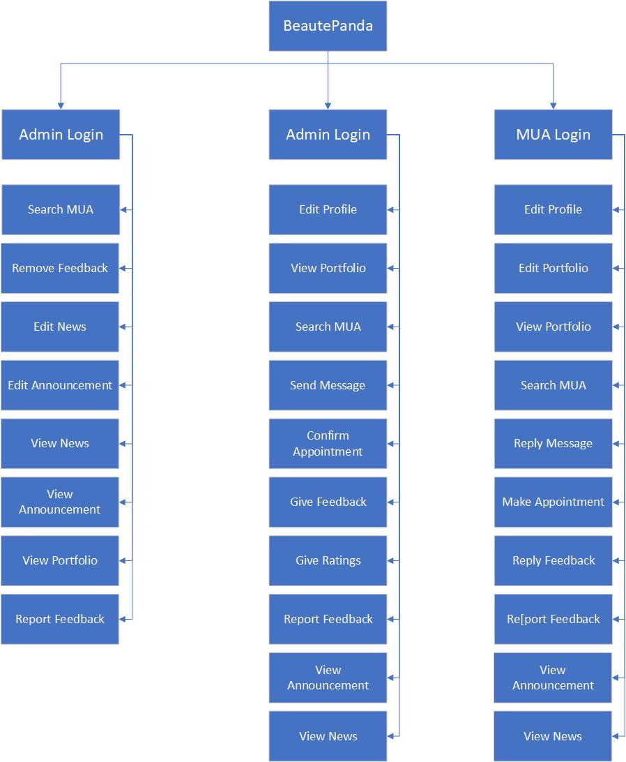**

Figure 4.22 Structural Design

##### 4.3.8.2.4 User Interface

###### 4.3.8.2.4.1 Colour Used

|  |  |  |
| --- | --- | --- |
| Color | Hex Color Code | Usage |
|  | #aaaaaa | Text, divider line |
|  | #7a7a7a | Notification bar |
|  | #FFFFFF | Background, icon, text |
|  | #FF1470 | Icon background, button, icon, text, header, navigation drawer header |
|  | #000000 | Text |
|  | #BDBDBD | Divider line, text |
|  | #ff4500 | Warning text |

Table 4.16 Colour Used of User Interface

###### 4.3.8.2.4.1 Interface Design

**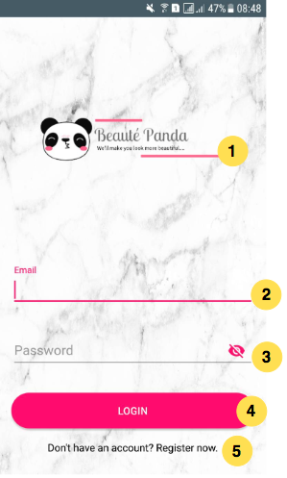**

Figure 4.23 Login User Interface

**Explanation:**

1. **Logo:** Logo of the application is placed in the middle
2. **Email Textbox:** User can type their email address that they already registered
3. **Password Textbox:** User can input their password that they already registered and user can hide or show the password while typing.
4. **Login Button:** After user complete the form with correct data, user can tap the login button to go to the main menu of the application
5. **Link Text:** If the user do not have an account they can tap the link that placed under the login button to make an account and complete the form

**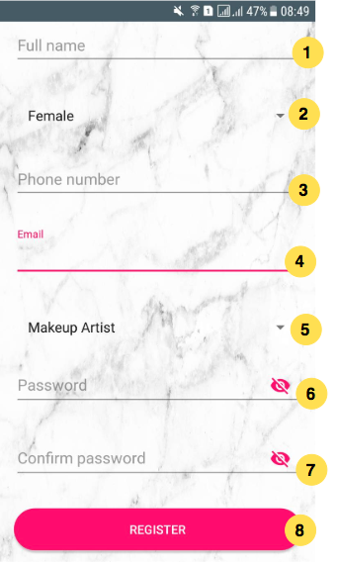**

Figure 4.24 Register User Interface

**Explanation:**

1. **Full Name Textbox:** User can input their full name in this textbox to complete the registration form
2. **Gender Dropdown:** User can select their gender (Female or Male) by clicking the dropdown menu
3. **Phone Number Textbox:** User can input their phone number in this textbox
4. **Email Textbox:** User can input their email address that they want to use to make an account in this application
5. **Status Dropdown:** User can select their status (Makeup Artist or Customer) by clicking the dropdown menu
6. **Password Textbox:** User can input their password that they want to use and user can hide or show the password while typing.
7. **Confirm Password Textbox:** User have to re – type the password in this textbox to ensure the password is match
8. **Register Button:** After user complete the registration form, user can tap the register button.

### 4.3.9 Implementation and Testing

#### 4.3.9.1 Implementation

In our project, we are using agile methodology to develop this application, and combine it with prototyping. By doing using this methodology, it allows us as the developers to work closely with the customers. It also allows some iterations to be changed later if it is more suitable for the customers’ needs. We are using IntelliJ Idea to create the tests because our application is based on Android. We have learnt Java programming language before so it is familiar for us. Nevertheless, there were many aspects of the testing that we didn’t know and we should learn from tutorials for guidance.

#### 4.3.9.2 Testing

Testing is very important part in developing an application. It needs to be done to ensure the quality of the application. This quality is not just the application can run well, but it also to check the the quality of user interface design and the code of the application. Testing also very important to ensure the application meets all the requirements that has been determined. In this Final Year Project 1, we tested our prototypes in two phases. The use case that we tested are the register and login.

##### 4.3.9.2.1 Unit Testing

| **Unit Test Plan** | | |
| --- | --- | --- |
| Module Name/ID: Register | Program Name/ID: BeautéPanda |
| **1. Module Overview** | | |
| Allow user to register for a new account. | | |
|  | | |
| **1.1 Inputs to Module** | | |
| * Full Name (Varchar) * Gender (Varchar) * Phone Number (Varchar) * Email (Varchar) * Status (Varchar) * Password (Varchar) * Confirm Password (Varchar) | | |
|  | | |
| **1.2 Outputs from Module** | | |
| New user has registered successfully and the information is stored in the database. System will show message to notify user that registration is successful. | | |
|  | | |
| **1.3 Logic Flow Diagram/Segment of Code** | | |
| **public class** RegisterActivityTest {   @Rule  **public** ActivityTestRule<RegisterActivity> **registerActivityTestRule** = **new** ActivityTestRule<RegisterActivity>(RegisterActivity.**class**);   @Before  **public void** setUp() **throws** Exception {  }   String **fullName** = **"Test fullname"**;  String **phoneNumber** = **"08123456788"**;  String **email** = **"test@example.com"**;  String **password** = **"password"**;  String **confirmPassword** = **"password"**;  String **wrongConfirmPassword** = **"wrongpassword"**;  String **successString** = **"User created successfully!"**;  String **failString** =**"Password does not match"**;   @Test  **public void** testUserRegister(){  *onView*(*withId*(R.id.***editTextFullName***)).perform(*typeText*(**fullName**), *closeSoftKeyboard*());  *onView*(*withId*(R.id.***editTextPhoneNumber***)).perform(*typeText*(**phoneNumber**), *closeSoftKeyboard*());  *onView*(*withId*(R.id.***editTextEmail***)).perform(*typeText*(**email**), *closeSoftKeyboard*());  *onView*(*withId*(R.id.***editTextPassword***)).perform(*typeText*(**password**), *closeSoftKeyboard*());  *onView*(*withId*(R.id.***editTextConfirmPassword***)).perform(*typeText*(**confirmPassword**), *closeSoftKeyboard*());  *onView*(*withId*(R.id.***buttonRegister***)).perform(*click*());  *onView*(*withText*(**successString**)).check(*matches*(*isDisplayed*()));  }   @Test  **public void** testUserRegisterFailed(){  *onView*(*withId*(R.id.***editTextFullName***)).perform(*typeText*(**fullName**), *closeSoftKeyboard*());  *onView*(*withId*(R.id.***editTextPhoneNumber***)).perform(*typeText*(**phoneNumber**), *closeSoftKeyboard*());  *onView*(*withId*(R.id.***editTextEmail***)).perform(*typeText*(**email**), *closeSoftKeyboard*());  *onView*(*withId*(R.id.***editTextPassword***)).perform(*typeText*(**password**), *closeSoftKeyboard*());  *onView*(*withId*(R.id.***editTextConfirmPassword***)).perform(*typeText*(**wrongConfirmPassword**), *closeSoftKeyboard*());  *onView*(*withId*(R.id.***buttonRegister***)).perform(*click*());  *onView*(*withText*(**failString**)).check(*matches*(*isDisplayed*()));  }   @After  **public void** tearDown() **throws** Exception {  } } | | |
|  | | |
| **2. Test Data** | | |
| 1. Valid Data  * Full Name: Test fullname * Gender: Female * Phone Number: 08123456788 * Email: [test@example.com](mailto:test@example.com) * Status: Makeup Artist * Password: password * Confirm Password: password  1. Invalid Data  * Full Name: Test fullname * Gender: Female * Phone Number: 08123456788 * Email: [test@example.com](mailto:test@example.com) * Status: Makeup Artist * Password: password * Confirm Password: wrongpassword (password confirmation does not match) | | |
|  | | |
| **2.1 Positive Test Cases** | | |
| * Full Name: Test fullname * Gender: Female * Phone Number: 08123456788 * Email: [test@example.com](mailto:test@example.com) * Status: Makeup Artist * Password: password * Confirm Password: password   This is an example of valid input data. Data/information inputted in accordance with requested data type. All columns filled, no empty column. This valid data then will be stored in the database and system will display a massage that says “User created successfully”. | | |
|  | | |
| **2.2 Negative Test Cases** | | |
| * Full Name: Test fullname * Gender: Female * Phone Number: 08123456788 * Email: [test@example.com](mailto:test@example.com) * Status: Makeup Artist * Password: password   Confirm Password: wrongpassword (password confirmation does not match)  This is an example of invalid input data. This will happen if the data/information inputted in the column is not complete or does not fit with requested data (i.e., password confirmation does not match). This invalid data will not be stored in the database and system will display a massage that says “Password does not match”. | | |
|  | | |
| **3. Interface Modules** | | |
| 1. Positive Test Case     Figure 4.25 Positive Test Case: Register   1. Negative Test Case     Figure 4.26 Negative Test Case: Register with Wrong Confirmation Password | | |
|  | | |
| **4. Test Tools** | | |
| This system is tested on smartphones (Samsung Galaxy A5 2016). Android version used in this testing are Android 7.0 Nougat. | | |
| Table 4.17 Register Unit Test Plan   | **Unit Test Plan** | | | --- | --- | | Module Name/ID: Log In | Program Name/ID: BeautéPanda | | **1. Module Overview** | | | Allow registered user to log in | | |  | | | **1.1 Inputs to Module** | | | * Email (Varchar) * Password (Varchar) | | |  | | | **1.2 Outputs from Module** | | | User with registered account can log into the system. After log in, system will display message that log in is successful. | | |  | | | **1.3 Logic Flow Diagram/Segment of Code** | | | **public class** LoginActivityTest {   @Rule  **public** ActivityTestRule<LoginActivity> **loginActivityTestRule** = **new** ActivityTestRule<LoginActivity>(LoginActivity.**class**);   **private** String **email** = **"test@example.com"**;  **private** String **password** = **"password"**;  **private** String **wrongPassword** = **"wrongpassword"**;  **private** String **successString** = **"Successfully Logged in!"**;  **private** String **failString** = **"Failed to log in , please try again"**;   @Before  **public void** setUp() **throws** Exception {  }   @Test  **public void** testUserLogin(){  *onView*(*withId*(R.id.***editTextEmail***)).perform(*typeText*(**email**), *closeSoftKeyboard*());  *onView*(*withId*(R.id.***editTextPassword***)).perform(*typeText*(**password**), *closeSoftKeyboard*());  *onView*(*withId*(R.id.***buttonLogin***)).perform(*click*());  *onView*(*withText*(**successString**)).check(*matches*(*isDisplayed*()));  }   @Test  **public void** testUserLoginFailed(){  *onView*(*withId*(R.id.***editTextEmail***)).perform(*typeText*(**email**), *closeSoftKeyboard*());  *onView*(*withId*(R.id.***editTextPassword***)).perform(*typeText*(**wrongPassword**), *closeSoftKeyboard*());  *onView*(*withId*(R.id.***buttonLogin***)).perform(*click*());  *onView*(*withText*(**failString**)).check(*matches*(*isDisplayed*()));  }   @After  **public void** tearDown() **throws** Exception {  } } | | |  | | | **2. Test Data** | | | 1. Valid Data  * Email: test@example.com * Password: password  1. Invalid Data  * Email: test@example.com * Password: wrongpassword (confirmation password does not match) | | |  | | | **2.1 Positive Test Cases** | | | * Email: test@example.com * Password: password   This is an example of valid input data. All columns filled by user. System will check if email exists in the database and whether the password match. If the email and password match, system will display a massage that says “Successfully Logged in”. | | |  | | | **2.2 Negative Test Cases** | | | * Email: test@example.com * Password: wrongpassword   This is an example of invalid input data. This will happen if the data/information inputted in the column is not complete or incorrect (e.g., password is empty or password does not match with the account data in the database). If the password is wronf and is not found in the database, system will display a message that says “Failed to log in, please try again”. | | |  | | | **3. Interface Modules** | | | 1. Positive Use Case     Figure 4.27 Positive Use Case: Login with True Password   1. Negative Use Case     Figure 4.28 Negative Use Case: Login with Wrong Password | | |  | | | **4. Test Tools** | | | This system is tested on smartphones (Samsung Galaxy A5 2016). Android version used in this testing are Android 7.0 Nougat. | | |  | | | | |

Table 4.18 Login Unit Test Plan

##### 4.3.9.2.2 System Testing

Testing 1: Register use case

|  |  |  |  |  |
| --- | --- | --- | --- | --- |
| **Use Case Tested:** | | Register | | |
| **Test Description:** | | Testing the registration process for new user. This is to ensure that new user to the system | | |
| **Pre-conditions** | | User should fill all the columns from the registration form displayed by the system. | | |
| **Post-conditions** | | User register successfully and can log in to the system. | | |
| **Notes:** | |  | | |
| **Result (Pass/Fail/Warning/Incomplete)** | | Pass | | |
|  | **TEST STEP** | **EXPECTED TEST RESULTS** | **P** | **F** | |
|  | Register | User clicks the register now text and then the registration page opened | ✓ |  | |
|  | Unregistered user fills all fields from the registration form with valid data | User register a new account successfully to the system. | ✓ |  | |
|  | User does not input valid data or fill all the required data | A warning message will be displayed about which field is incorrectly filled. | ✓ |  | |

Table 4.19 Register System Testing

Testing 2: Log In use case

|  |  |  |  |  |
| --- | --- | --- | --- | --- |
| **Use Case Tested:** | | Log In | | |
| **Test Description:** | | Testing the login by the user. Ensure that user can log into the system | | |
| **Pre-conditions** | | User should have a registered account and fill the login form with valid email address and password. | | |
| **Post-conditions** | | User log in successfully. User enter the system and system displaying the home page. | | |
| **Notes:** | |  | | |
| **Result (Pass/Fail/Warning/Incomplete)** | | Pass | | |
|  | **TEST STEP** | **EXPECTED TEST RESULTS** | **P** | **F** |
| 1. | Log in | User presses the Log In button and then the login page opened | ✓ |  |
| 2. | User fills the form with valid email address and password | User logs in successfully to the system. | ✓ |  |
| 3. | User inputs invalid email address and password | System will display a warning message about what data the user did not fill correctly or no data inputted to the login form. | ✓ |  |

Table 4.20 Login System Testing

#### 4.3.9.3 Testing Phase Conclusion

The testing stage is crucial in developing any software. It is to assure developers that functions of the system are properly working. We have done unit testing and system testing. We tested two use cases which are register and login. In unit testing, we test positive and negative case to ensure the behaviour of the system is what we expected. In system testing, we want to find if there is any difference when the use case is tested using certain test step. After the testing have been done, the results are as we expected. Register and log in use case has passed the unit testing and system testing.

### 4.3.10 Iteration Review and Conclusion

All the iteration phases are finished as we have planned and it is in accordance with the project schedule. In developing this project, the iteration plan is very helpful in making the project on time and meet all requirements that are needed to develop the application. It also becomes a guidance in order to develop the project properly. Despite having some problems and difficulties while developing this project and testing the system, we managed to do it as we expected.

# CHAPTER 5: CONCLUSIONS

## 5.1 Introduction

In this chapter, we will discuss all the shortcomings we faced and its solution. We also will discuss what went right and wrong during developing this project, lesson we learned from this Final Year Project 1, the further improvement, and the future work for this project.

## 5.2 Shortcomings and Solutions

1. **Lack of Experience and Knowledge in Developing Android Application**

We have no experience and we have never learned to develop Android application before. The lack of this experience and knowledge can be solved by learning from the books, internet, consult with our supervisor, and watching the video tutorial to understand step by step the process of developing an Android application.

1. **Communication**

While developing this project, we mostly meet up to discuss about the project when we have class on campus and we rarely had time to meet up outside the class schedule on campus to discuss about the project on campus. It is because we have other assignments and projects that we have to complete.

To overcome this problem, our solutions is to use Line (instant messaging application) to communicate about the project since communication is important while working as a team to solve the problem. We also use Google Drive to share the project to each other and make evaluate about the project.

## 5.3 What Went Right

In this project, there are many tasks we have been completed and it is completed as we expected. Those tasks are as follows:

1. **Prototypes**

The prototypes of two use cases have been completed and it is worked as we expected. We watched the video tutorial as the guideline in order to develop the prototypes, so that the prototypes of our application worked well.

1. **Project Testing**

The project testing of two use cases which are register and login have been finished. We followed some guideline in order to test the prototypes. We also did not find any errors or bugs that occurred during project testing.

## 5.4 What Went Wrong

During developing the project, there are some problems that we have to face it and it causes a few things did not work well. Those things are as follows:

1. **Schedule**

We have planned our project schedule, but there are some things that make our project schedule is not in accordance with what we previously planned. It is because we have to take some times to learn the guideline in order to develop the application.

1. **Confusion when using IntelliJ Idea for the first time**

This is our first time develop Android project and using IntelliJ Idea, so we had some problems when operating the IDE. We have overcome this problem by learning tutorials and ask our seniors for guidance.

## 5.5 Lesson Learned

1. **Time Management**

Time management is important in developing a project. We need to manage our time in order to fulfil all the requirement before the deadline. In this Final Year Project 1, we have managed and completed two use cases and document in time.

1. **IntelliJ IDEA**

We develop this project using IntelliJ IDEA as an IDE in developing the application. This software is using Java as programming language. There are some things that make it different from the Java programming language that we learned in the class. These different things become a new lesson that we have to learn in developing this project

## 5.6 Further Improvement

In this Final Year Project 1, we have completed all requirement that are needed. We also have explained all use cases in this Final Year Project 1. However, there are some things that we need to explain more about our application and how it works. We also need to improve few things in our application such as the user interface design, in order to make our application looks better.

## 5.7 Future Work

In this Final Year Project 1, we have completed the prototypes and project testing for two use cases, which are register and login. We also completed the documentation for the Final Year Project 1. We also need to fulfil all requirement that are needed for the application so that in the future, our application can be useful for all users to help them in order to find the makeup artists or beauty salons.

## 5.8 Conclusions

BeautéPanda is an Android application for beauty enthusiasts in Bali. This mobile application will let the user to find makeup artists or beauty salons, make an appointment with them, read about beauty related news, and it also let the user to send the message to MUAs or beauty salons in order to find further information. We have already made the analysis artefact and design artefact for 20 uses cases for this project. However, we already completed the prototypes and project testing for two use cases, which are register and login page.

In developing this project, we got many experiences and we also gained a lot of lessons. We learned about time management and Android application development. With all of the lesson and experience, we hope that it will help us in developing the project and fulfil all of the requirement that are needed in order to complete the project

# REFERENCES

Cockburn, A. (2002). *Agile Software Development.* Boston: Addison-Wesley.

Moertini, V. S., Suhok, Heriyanto, S., & Nugroho, C. D. (2014). REQUIREMENT ANALYSIS METHOD OF ECOMMERCE WEBSITES DEVELOPMENT FOR SMALLMEDIUM ENTERPRISES, CASE STUDY: INDONESIA. *International Journal of Software Engineering & Applications (IJSEA)* *, 5* (2), 12 - 13.

# APPENDIX A: Gantt Chart

# APPENDIX B: Progress Reports

# Description: Macintosh HD:Users:yongyl:Dropbox:Public:HELPGroup_Logos_HU.pngAPPENDIX C: Meeting Report

**BIT304 MEETING REPORT**

|  |
| --- |
| Semester & Year : VII – 2018 |
| Project Title : BeautéPanda: Android Application for Beauty Enthusiasts |
| Supervisor Name : Yudi Agusta, Ph.D. |
| Student Name & IDs : 1. Ayu Chrisniyanti – E1500352  2. Lovely Tedjamulja – E1500367 |
| Date & Start Time – End Time : 28th September 2018 (18.00 pm – 19.00 pm) |
| Punctual (Y/N) : (Y) |

1. Progress from previous meeting

This is our first meeting with supervisor

1. Project Management – Check Gantt Chart and tasks completed based on timelines

We are discussing about the project theme and its function of our application

1. Prototype Development – Check progress for prototype development

The development of the prototypes has not started yet

1. Work required by next meeting

The work is required for the next meeting is to complete the project plan and submit the chapter I (project plan)

Student(s)’ Signature Supervisor’s Signature

Ayu Chrisniyanti – Lovely Yudi Agusta, Ph.D.

Date: 28th September 2018 Date: 28th September 2018



**BIT304 MEETING REPORT**

|  |
| --- |
| Semester & Year : VII – 2018 |
| Project Title : BeautéPanda: Android Application for Beauty Enthusiasts |
| Supervisor Name : Yudi Agusta, Ph.D. |
| Student Name & IDs : 1. Ayu Chrisniyanti – E1500352  2. Lovely Tedjamulja – E1500367 |
| Date & Start Time – End Time : 4th October 2018 (18.00 pm – 18.30 pm) |
| Punctual (Y/N) : (Y) |

* Progress from previous meeting

We discussed about the project theme and its function for our project

1. Project Management – Check Gantt Chart and tasks completed based on timelines

In the second meeting, we discussed about the use cases of our application

1. Prototype Development – Check progress for prototype development

The development of the prototypes has not started yet

1. Work required by next meeting

The work is required for the next meeting is to complete the project plan and submit the chapter I (project plan)

Student(s)’ Signature Supervisor’s Signature

Ayu Chrisniyanti – Lovely Yudi Agusta, Ph.D.

Date: 28th September 2018 Date: 28th September 2018



**BIT304 MEETING REPORT**

|  |
| --- |
| Semester & Year : VII – 2018 |
| Project Title : BeautéPanda: Android Application for Beauty Enthusiasts |
| Supervisor Name : Yudi Agusta, Ph.D. |
| Student Name & IDs : 1. Ayu Chrisniyanti – E1500352  2. Lovely Tedjamulja – E1500367 |
| Date & Start Time – End Time : 22nd November 2018 (18.00 pm – 18.30 pm) |
| Punctual (Y/N) : (Y) |

1. Progress from previous meeting

This is our third meeting with the supervisor. In the previous meeting, we discussed about the use cases of the application

1. Project Management – Check Gantt Chart and tasks completed based on timelines

In this meeting, we discussed about the progress of the project and we also discussed about the sequence diagram

1. Prototype Development – Check progress for prototype development

The development of the prototypes has not started yet

1. Work required by next meeting

The work is required for the next meeting is to complete the iteration plan and submit the chapter 4

Student(s)’ Signature Supervisor’s Signature

Ayu Chrisniyanti – Lovely Yudi Agusta, Ph.D.

Date: 28th September 2018 Date: 28th September 2018



**BIT304 MEETING REPORT**

|  |
| --- |
| Semester & Year : VII – 2018 |
| Project Title : BeautéPanda: Android Application for Beauty Enthusiasts |
| Supervisor Name : Yudi Agusta, Ph.D. |
| Student Name & IDs : 1. Ayu Chrisniyanti – E1500352  2. Lovely Tedjamulja – E1500367 |
| Date & Start Time – End Time : 6th December 2018 (18.00 pm – 18.30 pm) |
| Punctual (Y/N) : (Y) |

1. Progress from previous meeting

In previous meeting, we discussed about the progress of the project and we also discussed about the sequence diagram

1. Project Management – Check Gantt Chart and tasks completed based on timelines

In this meeting with the supervisor, we discussed about analysis class diagram

1. Prototype Development – Check progress for prototype development

The development of the prototypes has not started yet

1. Work required by next meeting

The work is required for the next meeting is to complete the iteration plan and submit the chapter 4

Student(s)’ Signature Supervisor’s Signature

Ayu Chrisniyanti – Lovely Yudi Agusta, Ph.D.

Date: 28th September 2018 Date: 28th September 2018

# APPENDIX D: Minutes of Meetings

**BIT304 Final Year Project I**

**BeautéPanda: Android Application for Beauty Enthusiasts**

**Minutes No. 1**

Date : Tuesday, 2October 2018

Time : 9.00 am – 1.00 pm

Venue : Niya’s house

Present :

Lovely  *Chairperson*

Ayu Chrisniyanti *Secretary*

Absent with apologies: - Represented by -

|  |  |  |
| --- | --- | --- |
| **No.** | **Matters Discussed** | **Action By** |
| **1.0** | **Topic 1: Identifying the Idea** | All Member |
| 1.1 | Discussing the possible idea for the project by identifying the problems exist in the daily life | All Member |
| 1.2 | Discussing what is the solution that the project offers to solve the problem | All Member |
| 1.3 | Discussing the target user | All Member |
|  |  |  |
| **2.0** | **Topic 2: The Functions in Our Project** | All Member |
| 2.1 | Discussing the functions that will be provided by our project | All Member |
|  |  |  |
| **3.0** | **AOB** |  |
|  | There being no other matters, the meeting adjourned at 1.00 pm |  |

Minute by: Ayu Chrisniyanti

Verified by: Lovely

**BIT304 Final Year Project I**

**BeautéPanda: Android Application for Beauty Enthusiasts**

**Minutes No. 2**

Date : Monday, 8 October 2018

Time : 9.00 am – 1.00 pm

Venue : Lovely’s house

Present :

Lovely  *Chairperson*

Ayu Chrisniyanti *Secretary*

Absent with apologies: - Represented by -

|  |  |  |
| --- | --- | --- |
| **No.** | **Matters Discussed** | **Action By** |
| **1.0** | **Topic 1: Project Background, Aims, and Objectives** | All Member |
| 1.1 | Discussing the project background of our project | All Member |
| 1.2 | Discussing the aims and objectives of our project | All Member |
|  |  |  |
| **2.0** | **Topic 2: Methodology and Technique** | All Member |
| 2.1 | Discussing the methodology that is suitable with our project | All Member |
| 2.2 | Discussing the techniques used in developing the project and testing the system | All Member |
|  |  |  |
| **3.0** | **AOB** |  |
|  | There being no other matters, the meeting adjourned at 1.00 pm |  |

Minute by: Ayu Chrisniyanti

Verified by: Lovely

**BIT304 Final Year Project I**

**BeautéPanda: Android Application for Beauty Enthusiasts**

**Minutes No. 3**

Date : Thursday, 18October 2018

Time : 9.00 am – 12.00 pm

Venue : International Class 1

Present :

Lovely  *Chairperson*

Ayu Chrisniyanti *Secretary*

Absent with apologies: - Represented by -

|  |  |  |
| --- | --- | --- |
| **No.** | **Matters Discussed** | **Action By** |
| **1.0** | **Topic 1: Strategic, Work, and Resource Plan** | All Member |
| 1.1 | Discussing the strategic plan of the project | All Member |
| 1.2 | Discussing the work plan of our project | All Member |
| 1.3 | Discussing the resource plan for the project | All Member |
|  |  |  |
| **2.0** | **AOB** |  |
|  | There being no other matters, the meeting adjourned at 12.00 pm |  |

Minute by: Ayu Chrisniyanti

Verified by: Lovely

**BIT304 Final Year Project I**

**BeautéPanda: Android Application for Beauty Enthusiasts**

**Minutes No. 4**

Date : Monday, 22October 2018

Time : 8.00 am – 1.00 pm

Venue : International Class 1

Present :

Lovely  *Chairperson*

Ayu Chrisniyanti *Secretary*

Absent with apologies: - Represented by -

|  |  |  |
| --- | --- | --- |
| **No.** | **Matters Discussed** | **Action By** |
| **1.0** | **Topic 1: Risk Management Plan** | All Member |
| 1.1 | Discussing the topic for each literature review | All Member |
|  |  |  |
| **2.0** | **AOB** |  |
|  | There being no other matters, the meeting adjourned at 1.00 pm |  |

Minute by: Ayu Chrisniyanti

Verified by: Lovely

**BIT304 Final Year Project I**

**BeautéPanda: Android Application for Beauty Enthusiasts**

**Minutes No. 5**

Date : Thurday, 1 November 2018

Time : 1.00 pm – 4.00 pm

Venue : International Class 1

Present :

Lovely  *Chairperson*

Ayu Chrisniyanti *Secretary*

Absent with apologies: - Represented by -

|  |  |  |
| --- | --- | --- |
| **No.** | **Matters Discussed** | **Action By** |
| **1.0** | **Topic 1: Literature Review** | All Member |
| 1.1 | Discussing the content of interim presentation | All Member |
| 1.2 | Preparing for the interim presentation | All member |
| **2.0** | **AOB** |  |
|  | There being no other matters, the meeting adjourned at 4.00 pm |  |

Minute by: Ayu Chrisniyanti

Verified by: Lovely

**BIT304 Final Year Project I**

**BeautéPanda: Android Application for Beauty Enthusiasts**

**Minutes No. 6**

Date : Sunday, 11 November 2018

Time : 11.00 am – 3.00 pm

Venue : Niya’s house

Present :

Lovely  *Chairperson*

Ayu Chrisniyanti *Secretary*

Absent with apologies: - Represented by -

|  |  |  |
| --- | --- | --- |
| **No.** | **Matters Discussed** | **Action By** |
| **1.0** | **Topic 1: Interim Presentation** | All Member |
| 1.1 | Review the content of interim presentation | All Member |
| 1.2 | Rehearsing for the interim presentation | All Member |
|  |  |  |
| **2.0** | **AOB** |  |
|  | There being no other matters, the meeting adjourned at 3.00 pm |  |

Minute by: Ayu Chrisniyanti

Verified by: Lovely

**BIT304 Final Year Project I**

**BeautéPanda: Android Application for Beauty Enthusiasts**

**Minutes No. 7**

Date : Wednesday, 14 November 2018

Time : 9.00 am – 1.00 pm

Venue : Lovely’s house

Present :

Lovely  *Chairperson*

Ayu Chrisniyanti *Secretary*

Absent with apologies: - Represented by -

|  |  |  |
| --- | --- | --- |
| **No.** | **Matters Discussed** | **Action By** |
| **1.0** | **Topic 1: Functional Requirement** | All Member |
| 1.1 | Discussing the functional requirement of the project | All Member |
| 1.2 | Discussing the use case diagram | All Member |
| 1.3 | Discussing the high-level use case | All Member |
| 1.4 | Discussing the expanded use case | All Member |
|  |  |  |
| **2.0** | **Topic 2: Non-Functional Requirement** | All Member |
| 2.1 | Discussing the non-functional requirement | All Member |
|  |  |  |
| **3.0** | **AOB** |  |
|  | There being no other matters, the meeting adjourned at 1.00 pm |  |

Minute by: Ayu Chrisniyanti

Verified by: Lovely

**BIT304 Final Year Project I**

**BeautéPanda: Android Application for Beauty Enthusiasts**

**Minutes No. 8**

Date : Tuesday, 27 November 2018

Time : 9.00 am – 1.30 pm

Venue : Lovely’s house

Present :

Lovely  *Chairperson*

Ayu Chrisniyanti *Secretary*

Absent with apologies: - Represented by -

|  |  |  |
| --- | --- | --- |
| **No.** | **Matters Discussed** | **Action By** |
| **1.0** | **Topic 1: Analysis Artefact** | All Member |
| 1.1 | Discussing the analysis class diagram of the project | All Member |
|  |  |  |
| **2.0** | **Topic 2: Design Artefact** | All Member |
| 2.1 | Discussing the sequence diagram of the project | All Member |
| 2.2 | Discussing the data needed in the database design | All Member |
|  |  |  |
| **3.0** | **AOB** |  |
|  | There being no other matters, the meeting adjourned at 1.30 pm |  |

Minute by: Ayu Chrisniyanti

Verified by: Lovely

**BIT304 Final Year Project I**

**BeautéPanda: Android Application for Beauty Enthusiasts**

**Minutes No. 9**

Date : Monday, 3 December 2018

Time : 9.00 am – 1.30 pm

Venue : Lovely’s house

Present :

Lovely  *Chairperson*

Ayu Chrisniyanti *Secretary*

Absent with apologies: - Represented by -

|  |  |  |
| --- | --- | --- |
| **No.** | **Matters Discussed** | **Action By** |
| **1.0** | **Topic 1: System Prototype** | All Member |
| 1.1 | Discussing all the use cases | All Member |
| 1.2 | Working on the sign up and login use case for the prototype | All Member |
|  |  |  |
| **2.0** | **Topic 2: Testing Phase** | All Member |
| 2.1 | Discussing the testing procedure | All Member |
| 2.2 | Working on the unit testing | All Member |
| 2.3 | Working on the system testing | All Member |
|  |  |  |
| **3.0** | **AOB** |  |
|  | There being no other matters, the meeting adjourned at 1.30 pm |  |

Minute by: Ayu Chrisniyanti

Verified by: Lovely

**BIT304 Final Year Project I**

**BeautéPanda: Android Application for Beauty Enthusiasts**

**Minutes No. 10**

Date : Monday, 10 December 2018

Time : 8.30 am – 1.00 pm

Venue : Lovely’s house

Present :

Lovely  *Chairperson*

Ayu Chrisniyanti *Secretary*

Absent with apologies: - Represented by -

|  |  |  |
| --- | --- | --- |
| **No.** | **Matters Discussed** | **Action By** |
| **1.0** | **Topic 1: Final Project Documentation** | All Member |
| 1.1 | Discussing all chapter in the final documentation | All Member |
| 1.2 | Final review for the final documentation | All Member |
|  |  |  |
| **2.0** | **AOB** |  |
|  | There being no other matters, the meeting adjourned at 1.00 pm |  |

Minute by: Ayu Chrisniyanti

Verified by: Lovely

**BIT304 Final Year Project I**

**BeautéPanda: Android Application for Beauty Enthusiasts**

**Minutes No. 11**

Date : Monday, 17 December 2018

Time : 9.00 am – 1.00 pm

Venue : Lovely’s house

Present :

Lovely  *Chairperson*

Ayu Chrisniyanti *Secretary*

Absent with apologies: - Represented by -

|  |  |  |
| --- | --- | --- |
| **No.** | **Matters Discussed** | **Action By** |
| **1.0** | **Topic 1: Project Evaluation** | All Member |
| 1.1 | Discussing each project evaluation | All Member |
|  |  |  |
| **2.0** | **Topic 2: Final Presentation** | All Member |
| 2.1 | Discussing the content for the final presentation | All Member |
| 2.2 | Preparing the video for prototype demonstration in the final presentation | All Member |
| 2.3 | Preparation for the whole final presentation | All Member |
|  |  |  |
| **3.0** | **AOB** |  |
|  | There being no other matters, the meeting adjourned at 1.00 pm |  |

Minute by: Ayu Chrisniyanti

Verified by: Lovely

# APPENDIX E: Project Evaluation

# APPENDIX F: Literature Review



**BeautéPanda: Android Application for Beauty Enthusiasts**

**BIT304 FINAL YEAR PROJECT I**

**LITERATURE REVIEW**

(E1500367) Lovely

Submitted to the

FACULTY OF COMPUTING AND DIGITAL TECHNOLOGY

(SCHOOL OF INFORMATION AND COMMUNICATION TECHNOLOGY)

In partial fulfilment of the requirements

for the degree of

Bachelor of Information Technology (HONS)

HELP UNIVERSITY

SEPTEMBER - DECEMBER 2018

1. **Introduction**

There is a proverb in the English language that says ‘beauty is in the eye of the beholder’ which means different people may have a different idea on what is considered attractive and beautiful. Regardless what the proverb says, the society often judges women by how they look and present themselves. Because of this issue, many women are using makeup to cover their flaws so they are considered beautiful and attractive by the public, especially the opposite gender. The earliest use of makeup can be traced back to ancient Egyptians era in 10,000 BC. At that time, men and women rouged their lips and cheeks, stained their nails with henna and lined their eyes and eyebrows heavily with kohl. Makeup was stored in special jars that were kept in special makeup boxes. Women would carry their makeup boxes to parties and keep them under their chairs (Chaudhri & Jain, 2009).

Today, similar practice can still be found, although men don’t wear makeup like in ancient Egyptians time anymore. We have lipstick and blush to give colors to the lips and cheeks, eyeliner to line the eyes and eyebrow pencil to make the brows thicker. However, one difference between the modern era and the Egyptians time is that women don’t really carry around makeup boxes to parties anymore. Women now are using beauty services to prepare their makeup and hair before the party starts. These services can be offered by makeup artists and beauty salons. Because the makeup is already done by professionals, women don’t have to worry about the makeup, thus it becomes unnecessary to bring makeup boxes to parties.

The use of makeup artists actually have started from the Egyptians time. They were actually servants for people from the higher class in the society, who could afford to hire someone to take care for their physical appearance. Only the rich and famous could afford makeup in the past, such as royals and theatre performers. Therefore, it can be said that the true original makeup artists were the servants to the wealthy, the wealthy themselves, or the theatre actors who did all of their own makeup (Christine, 2017).

In the 20th century, makeup artistry began to gain acceptance as a real profession due to several factors. The advancement in cinematographic technology allowed rapid development of films in early 20th century, which means the film industry required a lot of people to do the actresses’ makeup. This was the beginning of makeup artist being recognized as a real profession. Additionally, by the 1920s, the fashion show had gone mainstream. Retailers throughout the country staged shows, often in a store’s restaurant during lunch or teatime. This means that makeup artists were needed to paint the faces of the fashion models so they would become attractive during the show (Fortini, 2006). These factors contribute to popularity of makeup among the general public, as young women watched films and fashion shows at that time, they would want to look like the actresses and models. However not everybody had the skill to do their own makeup, thus it lead to the popularity of using the service of makeup artist by the general public.

Now in the 21st century, cosmetics are affordable and used by women from every social class. Because makeup is not exclusive to the rich and famous anymore, girls are taught by the society to experiment with makeup to increase their attractiveness from the young age. Different amounts can be applied as needed, and it works as a temporary boost in self-esteem. What is so appealing to most women about cosmetics is that it can be a quick an easy way to temporarily solve beauty problems (Britton, 2012).

Based on what we have discussed, we have created an android application called BeautéPanda to help women to find beauty services for special occasion that they have to attend, such as weddings, parties, graduation, etc. This application will also help the user to make appointment with the makeup artists or beauty salons that offer the beauty services. From the makeup artist point of view, this application will help them reach their target customers and become more known to the general public.

1. **Makeup as a Social Standard**

There is an unwritten rule that ‘require’ women to wear makeup and do something nice to their hair when they want to attend an event. It has become a standard in the society. However, this ‘rule’ is actually helpful because women who wear makeup will become more self-assured, and this can help them to socialize when attending an event. Wearing makeup helps women to increase their confidence because it is something that can be done quickly to improve their appearance temporarily (Scott, 2007).

Unfortunately, not every woman has the skills to do her own makeup nicely. It requires a lot of practice to become an expert in doing makeup, which can be time consuming and expensive. Hence, most women prefer to hire makeup artist or go to beauty salons to do their makeup and hair before attending an event. Because of this reason, makeup artist is needed to help women to meet the social standard of wearing beautiful makeup to attend events.

1. **Highlight of the Current Practices**

*Makeup customers still have some difficulties to compare makeup artists and contact them from one application*

At this time, customers who want to find makeup artist usually have to search through Instagram or Facebook because in those social media most makeup artists have an account to post photos of their makeup and their contact details. They have to search for hashtags such as #makeupartist or #makeupartistbali to find the service in their current location (for example in Bali for this case). The search result will be plenty, and the customers have to open the makeup artists’ account one by one to see the photos. If they are interested with some makeup artists, they have to contact the makeup artists one by one using other application, for example Whatsapp or Line. This is because usually the makeup artists do not respond to direct messaging in Instagram or Facebook.

*Makeup artists have troubles in offering their service and reaching the target market*

Currently, makeup artists do not have special application that can be the platform or marketplace to offer their service. They only use social media such as Instagram and Facebook to become known by the customer. Reaching the targeted customer is difficult if social media is the only way to promote themselves. Furthermore, most of these makeup artists do not have a physical building as their beauty studio, thus it is harder for them to be recognized by the customers.

*Existing beauty-related applications do not offer makeup and hairdo services*

There are applications such as Go-Glam, HouzCall, etc. in Indonesia where customers can order beauty treatments such as haircut and massages. However, those applications do not offer makeup and hairdo services, which are important in the beauty industry. Besides, the applications do not show the list of people who are available to provide the service and customers cannot select specific person to provide the service. This means customers cannot see the feedback from other customers after receiving the service from certain people from the applications.

1. **Proposed System**

In this modern time, makeup is important to many women from all social classes. It has become a necessity especially when there is an event that has to be attended. However, there are some difficulties to find people that offer makeup service because there is no application that gather all makeup artists and beauty salons in one platform. Because of this issue, the system that we have proposed will help to solve this problem. It is an android application where makeup artists and beauty salons can sign up and post photos and information about themselves. Customers can also sign up to search for the makeup artists and view their profile, read and give feedback, and contact the makeup artists directly within this application. In addition, there will be news section in the application where customers and makeup artists can read about beauty-related trends and information.

This application will also assist the customers to send messages directly to the makeup artists that the customers feel is interested with. Through this messaging feature, customers can ask for further information and if they want to use the service of that makeup artist, the makeup artist can ‘create an appointment’ where the customer should confirm. This is to make sure both parties have agreed to meet up for the makeup service to be delivered. After the confirmation, the appointment will go to order list and the application will send notification to both customers and the makeup artists so they will not forget about the meeting. The payment will be done directly by the customers to the makeup artist after the service has been given.

1. **Methodology and Technique Methodology**

**5.1 Methodology**

We are developing this system using Agile methodology. Considering that mobile application development is relatively new, we believe that more traditional approach such as Waterfall would not be suitable in developing mobile application. Mobile technology and trends are always changing, which means traditional software development methodologies would be unable to handle these challenges and the technical limitations that mobile market has (Khalid, Zahra, & Khan, 2014).

Agile is suitable for mobile application development because it is based on people and embracing their changing needs. It is a good approach for flexible and turbulent environment such as mobile market, where changes can happen anytime. Moreover, the team that develop the application using agile should have a main focus towards fulfilling customer requirements (Khalid, Zahra, & Khan, 2014). Therefore, we have chosen agile because the characteristics of mobile application development are aligned with the core value of agile and it is suitable for the ever-changing condition of mobile market.

**5.2 Technique**

For our project, we will use grey-box testing. It is a combination between white-box and black-box testing, where the tester has limited knowledge of the internal working of an application but has the knowledge of fundamental aspects of the system (Khan & Khan, 2012). The purpose of this testing is to any defect that may be created unintentionally because of improper structure or improper usage of applications (Acharya & Pandya, 2012).

We didn’t choose white box testing because this type of test should be carried out by expert tester and it requires the tester to look very thoroughly through the codes to find errors, which can be time consuming. We didn’t choose black box testing because we as the application developers have some knowledge about the system. Additionally, the test coverage might be limited. Because of the reasons above, we have decided to use grey-box testing as it is the most suitable for our application.

1. **Tools and Software to Be Used**

* **IntelliJ IDEA Community Edition**

IntelliJ IDEA is an integrated development environment that is suitable for creating web and android applications. However, we will be using community edition which is free and only works to develop android application. Regardless, it is hailed as the most intelligent and user friendly Java IDE, which can and will make the developers more productive. This is because IntelliJ IDEA is able to build its syntax tree, creating references between classes, variables, fields, methods, and their usages, analyzing the execution flow, and many more. Therefore, it can provide code completion to developer, help to quickly navigate through codes, and provide error analysis and suggestions to fix the errors (Cheptsov, 2016).

* **Gantt Project**

Gantt Project is an open source tool for project scheduling and management. This application will help us create tasks and milestones, organize tasks in a work breakdown structure, draw dependency constraints and create baselines (Gantt Project , 2018).  However, in Gantt Project, every task duration should be input as days and cannot be set as hours. It might also be confusing for beginners who just started using this application.

* **Adobe Photoshop**

Adobe Photoshop is a software for retouching digitized photographic images. We will be using this software to design the user interface, logo of our application and other graphic needs (Norr, 2018). The main advantage of using Adobe Photoshop is that there are plenty of design tools to use. However**, the interface can be very overwhelming to new users of the program** (Gaille, 2016)**.**

* **Microsoft Visio**

Microsoft Visio is a software to create diagrams. It offers a wide variety of built-in shapes, objects, and stencils to work with (Krause, 2017). We will be using this software because the user interface, functionality and user experience are very similar to Microsoft Office, thus it will be easy to use and navigate through. Moreover, it provides templates and general drawing tools which allow users to design professional looking diagrams and process objects quickly and easily (Rutherford, 2016).

1. **Challenges to Be Overcome**

*Lack of experience in developing an android application*

We have learned Java before and create simple desktop application, but we have never learned the implementation of Java in creating an android application. This also will be our first time working using IntelliJ IDEA. Because of this, we must do many research and learn from online tutorials to understand how to build an android application.

*Creating a beneficial and easy-to-use application*

We want our application to deliver the best user experience so that the users will be satisfied and loyal to our application. To reach this goal, we must carefully design the interface so that it will be easy to understand and use it. Furthermore, we are hoping that our users will get as many benefits as possible from using the application, so they are not wasting their time and phone memory for installing our application. Therefore, we have to design this application deliberately to meet the user requirements.

1. **Conclusion**

Beauty has always been an interesting subject that the society pays attention to. As time goes by, people from all social classes can afford to look more beautiful by getting their makeup and hair done. This is supported by the availability of cosmetics in the market and its price become more affordable. Makeup has become a need for women, whether it is for everyday activities or special events.

The popularity of makeup has created a new field of work for the beauty industry, which is makeup artists. This profession helps women to do their makeup and hairdo, to be ready to make an appearance in an event. On the other hand, it still difficult for customers to find makeup artists although demand for makeup is high. It is hard to find information about the makeup artists, contact them and make appointment within one application. Hence, to solve this problem, we are proposing to create and android application called BeautéPanda, which will help customers to find makeup artists, and facilitate makeup artists and beauty salons to offer their service and be known by their target customers.

# References

Acharya , S., & Pandya, V. (2012). Bridge between Black Box and White Box – Gray Box. *International Journal of Electronics and Computer Science Engineering* *, 2* (1), 175-184.

Britton, A. M. (2012). *The Beauty Industry's Influence on Women in Society.* University of New Hampshire.

Chaudhri, S., & Jain, N. (2009). History of cosmetics. *Asian Journal of Pharmaceutics* *, 3*, 164-167.

Cheptsov, A. (6 March, 2016). *Enjoying Java and Being More Productive with IntelliJ IDEA.* Retrieved from Jet Brains IntelliJ IDEA Blog: https://blog.jetbrains.com/idea/2016/03/enjoying-java-and-being-more-productive-with-intellij-idea/

Christine. (1 September, 2017). *A Brief History of Makeup Artistry*. Retrieved from Couturesque: https://www.couturesquemag.com/single-post/makeup-artists-history

Cockburn, A. (2002). *Agile Software Development.* Boston: Addison-Wesley.

Fortini, A. (8 February, 2006). *How the Runway Took Off*. Retrieved from SLATE: https://slate.com/culture/2006/02/a-brief-history-of-the-fashion-show.html

Gaille, B. (19 April, 2016). *8 Pros and Cons of Adobe Photoshop.* Retrieved from Brandon Gaille Small Business & Marketing Advice: https://brandongaille.com/8-pros-and-cons-of-adobe-photoshop/

*Gantt Project .* (2018). Retrieved from Gantt Project Official Web Site: https://www.ganttproject.biz/

Khalid, A., Zahra, S., & Khan, M. F. (2014). Suitability and Contribution of Agile Methods in Mobile Software Development. *I.J. Modern Education and Computer Science* (pp. 56-62). Pakistan: Modern Education and Computer Science Press.

Khan, F., & Khan, M. E. (2012). A Comparative Study of White Box, Black Box and Grey Box Testing Techniques. *International Journal of Advanced Computer Science and Applications* *, 3* (6), 12-15.

Krause, A. (1 February, 2017). *What is Microsoft Visio and What Does it Do?* Retrieved from Groovy Post: https://www.groovypost.com/reviews/microsoft-visio-explained/

Moertini, V. S., Suhok, Heriyanto, S., & Nugroho, C. D. (2014). REQUIREMENT ANALYSIS METHOD OF ECOMMERCE WEBSITES DEVELOPMENT FOR SMALLMEDIUM ENTERPRISES, CASE STUDY: INDONESIA. *International Journal of Software Engineering & Applications (IJSEA)* *, 5* (2), 12 - 13.

Norr, H. R. (2018). *Adobe Systems Incorporated.* Retrieved from ENCYCLOPÆDIA BRITANNICA: https://www.britannica.com/topic/Adobe-Systems-Incorporated#ref663631

Rutherford, K. (22 January, 2016). *Four Benefits of Designing Process Graphics in MS Visio.* Retrieved from Software toolbox: https://blog.softwaretoolbox.com/four-benefits-of-designing-process-graphics-in-ms-visio

Scott, S. (2007). *Influence of Cosmetics on the Confidence of College Women: An Exploratory Study.* Hanover College.



**BeautéPanda: Android Application for Beauty Enthusiasts**

**BIT304 FINAL YEAR PROJECT I**

**LITERATURE REVIEW**

(E1500352) Ayu Chrisniyanti

Submitted to the

FACULTY OF COMPUTING AND DIGITAL TECHNOLOGY

(SCHOOL OF INFORMATION AND COMMUNICATION TECHNOLOGY)

In partial fulfilment of the requirements

for the degree of

Bachelor of Information Technology (HONS)

HELP UNIVERSITY

SEPTEMBER - DECEMBER 2018

1. **Introduction**

Nowadays, smartphone is one example of technology that is becoming popular, global, and be a part of every person life. People around the world have adopted this technology as one of the most important facility that is needed in their everyday life. A variety of smartphones applications is available to be used in a wider range of usage situation. No doubt a smartphone is a new gadget that have ability to change people lives (Fawareh & Shaidah, 2017).

In the past, mobile phones were used only to make call or sending messages, but today mobile phones are changed into smartphones where it provides numerous functionalities and smartphones are not only used for communication anymore. With the growth of internet technology and its applications, now people are using smartphone for internet use such as sending and receiving email, chatting, sharing photos, and many more (Fawareh & Shaidah, 2017).

At present there are many mobile Operating Systems that available in the market such as Windows by Windows Inc., Symbian by Nokia, iOS by Apple Inc., and many more. But now, Android by Google and iOS by Apple Inc. are being the major players in building and developing mobile Operating System in the global market. Both platforms have grown more enterprise-friendly since about one decade (Bala, Sharma, & Kaur, 2015).

Android OS is a new next generation of mobile operating system and it is one of the most widely used mobile Operating System by the people these days. In 2003, Android was founded by Andy Rubin with company named Android Inc. in California. Entering 2005, Google was purchased Android and it was unveiled in 2007 with formation of OHA (Open Handset Alliance) led by Google. This Operating System is based on the Linux Kernel and it is developed by Google (Narmatha & Krishnakumar, 2016). (Lazareska & Jakimoski, 2017)

The iOS platform is developed by Apple Inc., iOS is the second most popular mobile OS these days after Android, and it is the world’s most advanced mobile Operating System these days. This OS was first released in 2007 and it developed only for iPhone, but later it was developed for iPod as well as iPad (Bharati, Ramith, & Amala, 2015). iOS is developed and it works exclusively on Apple’s products and devices. In 2017, Apple announced that iOS had 710 million active devices and it has sold more than 1.2 billion iOS devices (Lazareska & Jakimoski, 2017).

Based on what I have discussed above, we decided to develop a mobile application as a platform for our application. The reason we choose mobile application because it is running on smartphone where it easy to use and accessible from anywhere and any place, unlike website or desktop application. Also, mobile application is a new development and rapidly growing sector in global.

In this Era, many people are using mobile application to contact friends, browse the internet, sharing documents, and many more. The user can get facility of mobile application from everywhere and people can do many things in daily life or business life. Beside daily life got impact from mobile application, it gives and plays an important role in business life. many business companies in the world are earning revenue by using mobile application (Islam, Islam, & Mazumder, 2010). This makes people on society are using mobile application and smartphone often for daily life than any other platforms.

1. **Why We Choose Android**

Operating System that are developing by Google and Apple Inc. are the most popular in society these days. Even though, Apple Inc. developed iOS and it success to surpass the performance of any other Operating Systems include Android, because its features and its exclusivity.

Nowadays, the fact in the market is Android Operating System is growing faster than iOS and many people on society are using Android Operating System (Sheikh, Ganai, Malik, & Dar, 2013). Beside that some application developers are prefer to develop a mobile application with Android-based, because Android OS is open source which mean it is freely available and editable for application developers and it market share is 48.8% which is wider than iOS where iOS only has 17.2% of market share. Also, Android has the highest market size than any other existing Operating Systems (Divya & KrishnaKumar, 2016).

Android OS is the most widely used on society in 2012 until present. This Operating System is based on Linux Kernel and it is developed by Google, but later on it developed by Open Handset Alliance (OHA). It applications are usually developed in the Java language using the Android Software Development Kit, but the other development tools are available for developers, such as Native Development Kit for those developers that developed an application or extensions in C or C++ (Sheikh, Ganai, Malik, & Dar, 2013).

Besides Android provide an open development platform, Android also offers all the developers with the ability to develop and build an innovative application. Take advantages of the device hardware, set alarms, and many more are free for developers. In 2011, Google announced that their Android apps had been about 100.000 installed around the world (Sheikh, Ganai, Malik, & Dar, 2013).

Based on the analysis above, we have chosen Android to develop our project named BeautéPanda. Because it is open source OS and it offers a lot of convenience and flexibility for developers while developing a mobile application. Besides, Android OS is commonly used on society and it is becoming popular around the world, so it will make easier for us to reach more users to use our application.

1. **Similar Application**

Before we are developing our application, we were in the phase of gathering ideas. While in this phase, we did a lot of research about other applications that have similarity with our application that we want to develop named BeautéPanda. There are some mobile applications that provide some features that are similar with our application. But, all of those applications still cannot fulfil the user needs between Makeup Artists or Salons and the customers while making the appointment. There are the lists of some Android applications that have similarity with our application:

* **GO GLAM by GO-JEK**

GO GLAM is service that powered by GO-JEK. It is a beauty services that provide customers with manicure pedicure, cream-bath to waxing and the service is come directly to your home (GOJEK, 2017). However, for now this application only provides two services such as hair treatment and nails. This application still gets many comments from the user because the price offered is more expensive than salons in general (iTunes, 2017).

* **SALON by Houzcall**

This application is a mobile application that provides beauty services for the customers from hairstyling, haircut, manicure pedicure, and waxing to the place and time determined by you. This application provides the customer with booking menu where the customer can book for more than one person. However, this application did not provide the customer for makeup and for now, SALON by Houzcall only serves areas of Jakarta. This application provide electronic voucher called Houzcall Credit where the customer can use this voucher instead of cash to make payments and transactions (Houzcall, 2018).

1. **Methodology and Technique**
   1. **Methodology**

We have chosen to use Agile software development method for developing our project. This methodology involves many stakeholders and constantly showing them with the demonstrations of the current state of the software. This methodology also focused in around short iterative software release cycle. With this project, the stakeholders are allowed to make recommendations and suggest changes in the application while the software is being develop; so with this methodology, the developers can track what the customers actually desire (Charles Edeki, 2015).

Besides, the reason we choose Agile software development for this project because it will help us to improve the expectations of when the software or project will be complete, provide the ability to check the overall project progress easily, and many more (Charles Edeki, 2015). Agile software development is suitable for our project, because we can know what customers need while the software is being develop by giving feedback.

* 1. **Technique**

Testing is very important thing in software development. The main purpose of software testing is to ensure that the software produced is in accordance with requirements that previously determined. When the requirements of a system have been compiled, there should be a planning test. In addition, a testing process requires a final goal that can be assessed so that the tester can stop doing a test when the objectives are achieved (Kumar & Singh, 2015).

In this project, we will use Grey-box testing. Grey-box testing is a technique to test our application with limited knowledge of the internal working of an application and it also have knowledge about the basic aspects from the system. With this technique, we can verify both of the output from the user interface and also its process that leads to the user interface output. This Grey-box testing can be applied to most testing phases; However, mostly used in the integration testing (Bansal, 2014).

1. **Tools & Software to Be Used**

* **IntelliJ IDEA**

In this project we decided to use IntelliJ IDEA, because in developing this project we use Java language as the programming language and it is an integrated development environment (IDE). There is no different between this software and Android Studio, the Android plugins for both software are built from the same code and also all features on Android Studio are also available on IntelliJ IDEA (JetBrains, 2013).

The difference between IntelliJ IDEA and Android Studio is only from the RAM specification where the developers need 8GB RAM with processors i3 – i7 and SSD 128 or 152GB while using Android Studio if they want to develop the Android application without problems such as the software is not responding while developing the mobile application (Dotid, 2017).

* **Gantt Project**

We use Gantt Project as our tools to make and manage the project schedule before developing our project as the requirements that need to fulfil. We choose Gantt Project because it easier to use and more flexible while making and managing the project schedule.

* **Microsoft Visio Pro**

We decided to use Microsoft Visio Pro to make our project diagram from use case diagram, sequence diagram, database diagram, and many more. We choose this software because it easy to use and it has many libraries that make us easy to navigate.

* **Adobe Photoshop**

Adobe Photoshop is a photo editing and photo manipulation software that lets users to create and edit an images. In developing this project, we choose Adobe Photoshop to design our user interface as a sketch before we develop the application. Also, this software will help us to make the logo for our application and other graphic content needs.

1. **Challenges to Be Overcome**

* **Lack of experience in developing an android application**

We have no experience to develop an Android application before, but we have experience and we have learned Java programming languages and developed Java desktop application. However, we must do many practice and learn by watching the tutorial videos to develop this project and to understand step by step while developing the application.

* **Lack of experience in using IntelliJ IDEA for developing this project**

We have no experience developing an Android application with IntelliJ IDEA and this is our first time using IntelliJ IDEA as a software to develop an android application. We must do many research and learn to understand in term of using IntelliJ IDEA to develop an android application and to solve the problem that we face while developing our project.

1. **Conclusion**

An Android application is commonly and widely use in global for this Era by many people. With the highest market demand in global make this platform become popular year by year. We choose Android as the platform because it is an open-source code where it offers us as the developer more flexibility while developing the application.

In this Era, many beauty enthusiasts are facing the problem such as the difficulty to find makeup artists or beauty salons in one application and they still find it manually. However, we decided to develop an Android application namely BeautéPanda. We hope by developing this an Android mobile application can solve problems that are exists in beauty world. With our application, it will help the customers to find and meet with makeup artists or beauty salons and also facilitate both makeup artists and the customers with many features.

# References

Acharya , S., & Pandya, V. (2012). Bridge between Black Box and White Box – Gray Box. *International Journal of Electronics and Computer Science Engineering* *, 2* (1), 175-184.

Bala, K., Sharma, S., & Kaur, G. (2015). A Study on Smartphone based Operating System. *International Journal of Computer Applications* *, 121* (1), 17-19.

Bansal, A. (2014). A Comparative Study of Software Testing Techniques. *International Journal of Computer Science and Mobile Computing* *, 3* (6), 579-584.

Bharati, W., Ramith, N., & Amala, N. (2015). Mobile Operating System: Analysis and Comparison of Android and IOS. *IJCAT - International Journal of Computing and Technology* *, 2* (7), 273-280.

Britton, A. M. (2012). *The Beauty Industry's Influence on Women in Society.* University of New Hampshire.

Charles Edeki, P. (2015). AGILE SOFTWARE DEVELOPMENT METHODOLOGY. *European Journal of Mathematics and Computer Science* *, 2* (1), 22-27.

Chaudhri, S., & Jain, N. (2009). History of cosmetics. *Asian Journal of Pharmaceutics* *, 3*, 164-167.

Cheptsov, A. (2016, March 6). *Enjoying Java and Being More Productive with IntelliJ IDEA.* Retrieved from Jet Brains IntelliJ IDEA Blog: https://blog.jetbrains.com/idea/2016/03/enjoying-java-and-being-more-productive-with-intellij-idea/

Christine. (2017, September 1). *A Brief History of Makeup Artistry*. Retrieved from Couturesque: https://www.couturesquemag.com/single-post/makeup-artists-history

Cockburn, A. (2002). *Agile Software Development.* Boston: Addison-Wesley.

Divya, K., & KrishnaKumar, S. V. (2016). COMPARATIVE ANALYSIS OF SMART PHONE OPERATING SYSTEMS ANDROID, APPLE iOS AND WINDOWS . *International Journal of Scientific Engineering and Applied Science (IJSEAS)* *, 2* (2), 432-438.

Dotid, F. (2017, January 14). *Rekomendasi Spesifikasi Laptop untuk Menggunakan Android Studio*. Retrieved October 22, 2018, from Medium: https://medium.com/@farizdotid/rekomendasi-spesifikasi-laptop-untuk-menggunakan-android-studio-fa8cd4091bfb

Fawareh, H. M., & Shaidah, J. (2017). The Use and Effects of Smartphones in Higher Education. *International Journal of Interactive Mobile Technologies* *, 11* (6), 103-104.

Fortini, A. (2006, February 8). *How the Runway Took Off*. Retrieved from SLATE: https://slate.com/culture/2006/02/a-brief-history-of-the-fashion-show.html

Gaille, B. (2016, April 19). *8 Pros and Cons of Adobe Photoshop.* Retrieved from Brandon Gaille Small Business & Marketing Advice: https://brandongaille.com/8-pros-and-cons-of-adobe-photoshop/

*Gantt Project .* (2018). Retrieved from Gantt Project Official Web Site: https://www.ganttproject.biz/

GOJEK. (2017, January 01). *Persona Stylist at Your Home*. Retrieved October 23, 2018, from Go-Glam: https://www.go-jek.com/go-glam/

Houzcall, S. (2018, February 12). *FAQ*. Retrieved October 23, 2018, from Salon by Houzcall: https://salon.co.id/faq

Islam, M. R., Islam, M. R., & Mazumder, T. A. (2010). Mobile Application and Its Global Impact. *ternational Journal of Engineering & Technology* *, 10* (6), 72-77.

iTunes. (2017, January 01). *App Store Preview*. Retrieved October 23, 2018, from GO-LIFE | On Demand Lifestyle: https://itunes.apple.com/us/app/go-life-on-demand-lifestyle/id1192681273?mt=8

JetBrains. (2013, May 16). *IntelliJ IDEA and Android Studio FAQ* . Retrieved October 23, 2018, from IntelliJ IDEA Blog: https://blog.jetbrains.com/idea/2013/05/intellij-idea-and-android-studio-faq/

Khalid, A., Zahra, S., & Khan, M. F. (2014). Suitability and Contribution of Agile Methods in Mobile Software Development. *I.J. Modern Education and Computer Science* (pp. 56-62). Pakistan: Modern Education and Computer Science Press.

Khan, F., & Khan, M. E. (2012). A Comparative Study of White Box, Black Box and Grey Box Testing Techniques. *International Journal of Advanced Computer Science and Applications* *, 3* (6), 12-15.

Krause, A. (2017, February 1). *What is Microsoft Visio and What Does it Do?* Retrieved from Groovy Post: https://www.groovypost.com/reviews/microsoft-visio-explained/

Kumar, M., & Singh, S. K. (2015). A Comparative Study of Black Box Testing and White Box Testing Techniques. *International Journal of Advance Research in Computer Science and Management Studies* *, 3* (10), 32-44.

Lazareska, L., & Jakimoski, K. (2017). Analysis of the Advantages and Disadvantages of Android and iOS Systems and Converting Applications from Android to iOS Platform and Vice Versa . *American Journal of Software Engineering and Applications* *, 6* (5), 116-120.

Moertini, V. S., Suhok, Heriyanto, S., & Nugroho, C. D. (2014). REQUIREMENT ANALYSIS METHOD OF ECOMMERCE WEBSITES DEVELOPMENT FOR SMALLMEDIUM ENTERPRISES, CASE STUDY: INDONESIA. *International Journal of Software Engineering & Applications (IJSEA)* *, 5* (2), 12 - 13.

Narmatha, M., & Krishnakumar, S. V. (2016). Study on Android Operating System And Its Versions. *International Journal of Scientific Engineering and Applied Science* *, 2* (2), 439.

Norr, H. R. (2018). *Adobe Systems Incorporated.* Retrieved from ENCYCLOPÆDIA BRITANNICA: https://www.britannica.com/topic/Adobe-Systems-Incorporated#ref663631

Rutherford, K. (2016, January 22). *Four Benefits of Designing Process Graphics in MS Visio.* Retrieved from Software toolbox: https://blog.softwaretoolbox.com/four-benefits-of-designing-process-graphics-in-ms-visio

Scott, S. (2007). *Influence of Cosmetics on the Confidence of College Women: An Exploratory Study.* Hanover College.

Sheikh, A. A., Ganai, P. T., Malik, N. A., & Dar, K. A. (2013). Smartphone: Android Vs IOS. *The SIJ Transactions on Computer Science Engineering & its Applications (CSEA)* *, 1* (4), 141-148.

# APPENDIX G: Project Plan

****

**BACHELOR OF INFORMATION TECHNOLOGY (HONS)**

**BIT304**

**Final Year Project I**

**PROJECT PLAN**

**BeautéPanda: Android Application for Beauty Enthusiasts**

**PROJECT PERIOD: 28th September 2018 – 28th December 2018**

**Student Name: Ayu Chrisniyanti Student Id: E1500352**

**Student Name: Lovely Student Id: E1500367**

**15 Jalan Sri Semantan 1, Off Jalan Semantan, Bukit Damansara, 50490 Kuala Lumpur, Malaysia.**

**Tel : 603-2716 2000, Fax : 603 - 2095 7100**

* + - 1. **Project Title**

The title of our project is  title is BeautéPanda: Android Application for Beauty Enthusiasts. It is an an android application that serves as a place of commerce that connects customers with sellers who offer makeup, hairdo and nails services. This application has two types of user, which are customer and seller (salon or makeup artist). Through this application, a user can register as a customer and he/she will be able to find salons or makeup artists and read information about the services offered. The user can also find information about the latest beauty trends.

* + - 1. **Project Members**

|  |  |  |
| --- | --- | --- |
| **No** | **Student ID** | **Name** |
| 1 | E1500352 | Ayu Chrisniyanti |
| 2 | E1500367 | Lovely |

* + - 1. **Project Keywords**
* Makeup Artist (MUA)
* Salon or Beauty Salons
* Appointment
* Beauty Service Categories
* Seller
* Customer
  + - 1. **Project Background**

In this modern era, people want to look beautiful everyday especially for women. If we talk about beauty, it will always be related to makeup and hairdo. In recent years, the needs of beauty services are growing rapidly, because they have become as important as clothing for women. Due to these increasing needs, the services are not only offered by beauty salons, but also individuals that have skilled in makeup, hairdo and other beauty services. However, it is not easy to find these individuals, and it is hard for them to reach out to the targeted customer, since there is no platform that connect both of them.

The increasing popularity of beauty services also increases the number of individuals or businesses that offer these services. They are called makeup artist and beauty salons. However, there are so many of them which makes the customers confused to choose which makeup artist or salon that have good price, have better quality, etc. The other problem is that customer should find the information about makeup artists one by one in the internet or social media such an *Instagram*. This process of searching for the suitable individuals/place to get the services will spend much of the customers’ time.

Therefore, we would like to solve the problems mentioned above by developing a mobile application. This android – based application will be called BeautéPanda. This application will help customer to find and compare makeup artist and beauty salons easily. The customer can also contact the makeup artist directly through the ‘*inbox’* menu that will provided in the application, and make an appointment to deliver the service. From the seller’s (makeup artist and beauty salon) point of view, this application will facilitate them to promote his/her service.

1. **Aims of The Project**

The aim of this project is to create an android application called BeautéPanda, which serves as a market place where people who are self-employed as makeup artist can offer their services and make themselves known to the customer. This application is also for beauty salons that have already had physical building for their business, but want to reach more customers by offering their services through this application. We also want to help customer finding the perfect makeup/hairdo/nails for any occasion, contact the seller and make an appointment, all from one application. Other than that, this application is also intended to give users information about beauty – related news.

1. **Objectives of The Project**

There are several objectives that we should set to develop BeautéPanda, which are:

* Facilitate user (as customer) to search for a makeup artist or salon that offer the service he/she needs
* Facilitate user (as sellers) to offer their service and reach the customer
* Assist customer and seller to chat each other to make an appointment and confirm the order
* Provide a reminder feature so that both users will not forget about an appointment
* Let administrator to manage content of the news section and help section

1. **Direct Customers/Beneficiaries of The Project**

This application will be used for both the customers and sellers, which are makeup artist and beauty salons. For the sellers, they can upload their photos of beauty services and add description to attract customers, which will benefit them because they can promote their business and will be known by the customer. They will also get income when customer ‘buy’ their services. For the customers, this application will help finding information about the sellers and making appointment easier. The customers that will be using this application are mainly teen and adult women. The beauty services offered can also be for children, but since they are still young, they will not directly use the application to get a service.

1. **Outputs Expected from The Project**

Details of works and tasks done by each team member:

1. Ayu Chrisniyanti

* Develop project background
* Develop project schedule
* Literature reviews
* Requirement gathering
* User interface design
* Develop use case
* Develop class and sequence diagram
* Develop and testing prototype
* Develop database design
* Develop software methodology
* Requirement analysis

1. Lovely

* Develop aims of project and project objectives
* Develop work item list
* Develop resource plan list
* Risk management
* Literature reviews
* Requirement gathering
* Develop use case
* Develop class and sequence diagram
* Develop and testing prototype
* Develop software methodology
* Functional & non-functional requirements
* Structural design

1. **Organisations/Industries Involved In The Project** 
   1. STIKOM Bali
   2. HELP University
   3. Local beauty salons and makeup artists that provide data and photos to be used as samples in our application
2. **System Development Methodology**

The methodology that we will use for our project is Agile Methodology. This method has four core values which we view to be suitable in developing a mobile application in this digital and ever – changing era. These values are: individuals and interactions over processes and tools, working software over comprehensive documentation, customer collaboration over contract negotiation and responding to change over following a plan (Cockburn, 2002).

The core of agile software development methods can be defined as the use of light-but-sufficient rules of project behavior and the use of human- and communication-oriented rules. The agile process is both light and sufficient. Lightness is a means of remaining maneuverable. Sufficiency is a matter of staying in the game (Cockburn, 2002).

We choose Agile Methodology because it is a continuous cycle of improvement. Moreover, it focuses on communication between developers and users, and let the users participate in developing the application. This is better than the traditional development methodology because developer and user relation is not limited on the contract paper. This allows changes or additions to the application to meet the needs of users. We can have better understanding of the user and create our application to be as close as possible to what the users need.

1. **Risk Management Plan**

|  |  |  |  |  |
| --- | --- | --- | --- | --- |
| # | Description | Probability % | Impact  1= low  5 = high | Mitigation Strategy |
| 1 | Lacking the skills and knowledge to develop a wholesome android application | 40 | 5 | Find online sources to learn how to properly develop android application and find an expert to consult or to give guidance |
| 2 | The application produced will have many bugs | 40 | 5 | Run unit and integration testing to the codes to find bugs, and run system testing when the application prototype has been created |
| 3 | Project is not finished within project period | 20 | 5 | Regularly hold meetings between project members so that the project is not neglected |
| 4 | Not being able to produce proper UML diagram to show the workflow of the application | 30 | 4 | Revise previous lecture notes for creating UML diagram and consult with the project supervisor to give corrections to the diagram |
| 5 | Loss of data due to virus infection | 10 | 4 | Regularly make a backup for all the files related to the project |

1. **Work Item List**

|  |  |  |  |
| --- | --- | --- | --- |
| **Name / Description** | **Priority** | **Assigned To** | **Effort estimated (days)** |
| **Initiating** |  |  |  |
| Initial Meeting with Supervisor | High | Niya and Lovely | 1 |
| Project Theme Identification | High | Niya and Lovely | 1 |
| Supervisor Consultation | High | Niya and Lovely | 1 |
| Project Theme Decision | High |  | 0 |
| **Planning** |  |  |  |
| Develop Project Background | High | Niya | 2 |
| Develop Project Aims and Objectives | High | Lovely | 2 |
| Develop Work Item List | Medium | Lovely | 1 |
| Develop Project Schedule | Medium | Niya | 1 |
| Select Software Methodology | Medium | Niya and Lovely | 1 |
| Develop Resource Plan | Medium | Lovely | 1 |
| Develop Risk Management Plan | High | Lovely | 1 |
| Submission of Project Plan and Project Management Plan | High |  | 0 |
| **Executing** |  |  |  |
| Gathering Requirements | High | Niya and Lovely | 4 |
| Develop Literature Review | High | Niya and Lovely | 5 |
| Literature Review Submission | High |  | 0 |
| Prepare for Interim Presentation | Medium | Niya and Lovely | 9 |
| Interim Presentation | High |  | 0 |
| Develop Requirement Analysis | High | Niya | 3 |
| Develop Functional & Non-Functional Requirement | High | Lovely | 4 |
| Develop Use Case Diagram | Medium | Niya and Lovely | 2 |
| Chapter 3 Submission | High |  | 0 |
| Develop Analysis Class Diagram | High | Niya and Lovely | 1 |
| Develop Sequence Diagram | High | Niya and Lovely | 1 |
| Database Design | Medium | Niya | 1 |
| Structural Design | Medium | Lovely | 1 |
| User Interface Design | High | Niya | 4 |
| **Construction** |  |  |  |
| Coding for Prototype | High | Niya and Lovely | 3 |
| Testing | High | Niya and Lovely | 1 |
| Chapter 4 Submission | High |  | 0 |
| **Closing** |  |  |  |
| Develop Progress Report | High | Niya and Lovely | 6 |
| Prepare Final Documentation | High | Niya and Lovely | 3 |
| Final Report Submission | High |  | 0 |
| Final Presentation Preparation | High | Niya and Lovely | 4 |
| Final Presentation | High |  | 0 |

1. **Work Plan**

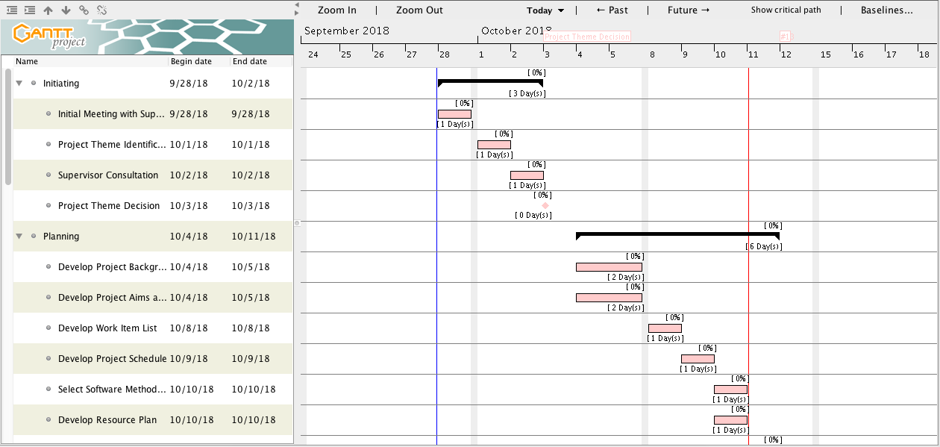

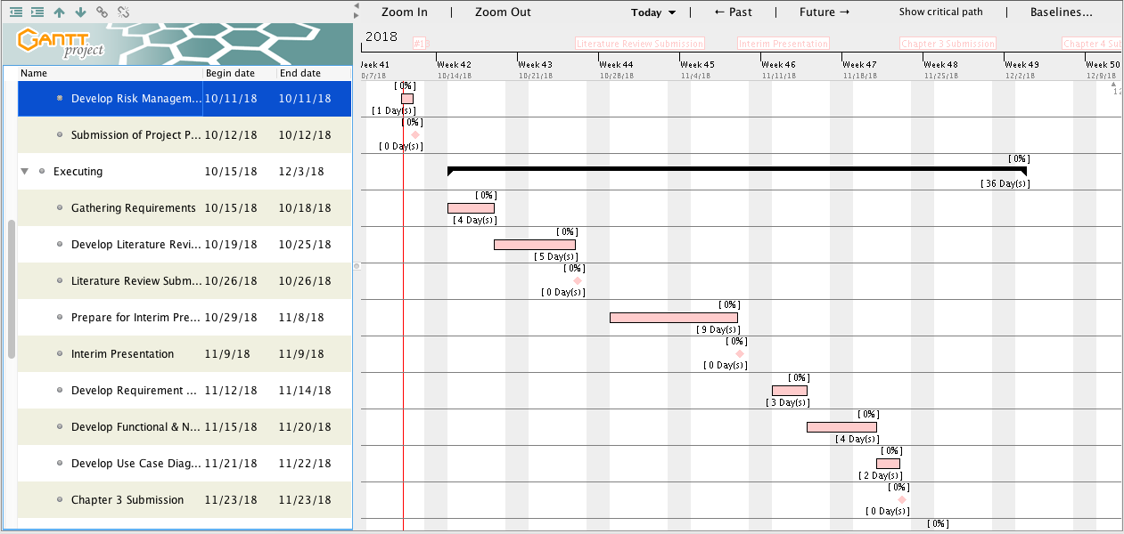

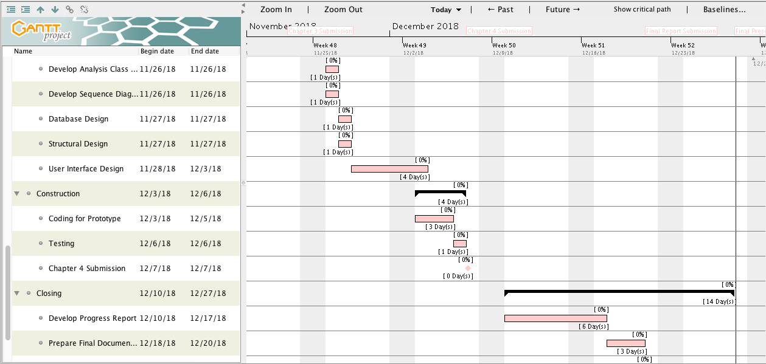

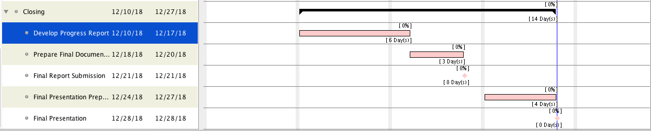

1. **Duration**

Starting Date : 28th September 2018

Duration/elapsed time : 4 months

End Date : 28th December 2018

1. **Project Resource Requirements and Estimated Costs\***

|  |  |  |  |  |
| --- | --- | --- | --- | --- |
| **No** | **Item** | **Usage** | **Qty.** | **Cost** |
| Hardware | | | | |
| 1 | ASUS laptop X450J series | Project development | 1 | Available |
| 2 | Apple MacBook Pro Mid 2012 | Project development | 1 | Available |
| 3 | Samsung Galaxy A5 | Project testing | 1 | Available |
| 4 | Epson L210 printer | Document printing | 1 | Available |
| Operating system | | | | |
| 5 | Windows 10 | Project development | - | Available |
| 6 | MacOS Sierra 10.12.3 | Project development | - | Available |
| 7 | Android Nougat 7.0 | Project testing | - | Available |
| Others | | | | |
| 8 | IntelliJ IDEA Community Edition 2018.2.4 | Android application development | - | Available |
| 9 | Adobe Photoshop CS6 | User interface design | - | Available |
| 10 | Microsoft Visio Pro 2013 | Drawing UML diagrams | - | Available |
| 11 | GanttProject 2.8.5 | Creating project schedule | - | Available |
| 12 | Microsoft Office Word 2013 | Creating project document | - | Available |
| 13 | Microsoft Office PowerPoint 2013 | Creating presentation for the project | - | Available |
| **Estimated Project Cost** | | | | Rupiah 0,- |

1. **Contractual Obligations Under This Project**

**Team Member**

Ayu Chrisniyanti E1500352

Lovely E1500367

1. **Code of Conduct**

As a project team, we will:

Work together to solve all problems encountered during the project

Develop a good relation with each other to support our teamwork so that we will finish on the due date

Distribute tasks and work items equally

Consider each other’s approach in developing the project

1. **Participation**

As a project team, we will:

* + - 1. Present in every meeting
      2. Responsible to do and finished the given tasks
      3. Help to solve problems in developing the project by giving solutions
      4. Open to any advice and suggestion to make the project better

1. **Communication**

As a project team, we will:

Clearly discuss the project goals and ideas

Communicate problems with each other and come up with the solution

Value each other’s view and opinion in developing the project

1. **Problem Solving**

As a project team, we will:

* + - 1. Communicate the problems in the project
      2. Give advice and suggestion to solve the problems
      3. Respect each other’s solution to solve the problems
      4. Provide a strategy to deal with problems that may have great impact to our project

1. **Meeting Guidelines**

As a project team, we will:

Decide on the project idea and distribute the tasks equally

Record the outcomes of every meeting

Use the necessary tools to finish the project

Evaluate the project result with the initial goal

1. **Ownership of Intellectual Property Rights**

All ownership and intellectual property belongs to HELP University

**PROJECT MEMBERS DECLARATION**

We hereby acknowledge that the all the information given above is true and correct to the best of our knowledge.

**Name :** Ayu Chrisniyanti

**Signature :**

**Date :**

**Name :** Lovely

**Signature :**

**Date :**

# References

Cockburn, A. (2002). *Agile Software Development.* Boston: Addison-Wesley.

# APPENDIX H: Project Outline



**Bachelor of Information Technology**

**(HONS)**

**BIT304**

**Final Year Project I**

**Project Outline Document**

**Student Name: Ayu Chrisniyanti Student ID: E1500352**

**Student Name: Lovely Student ID: E1500367**

1. **Project Title**

Our project title is BeautéPanda: Android Application for Beauty Enthusiasts. It is an application that provides services to connect customers and makeup artists or beauty salons. People can search for makeup artists or beauty salons, view their portfolio, and send them messages to ask more information.

Makeup artists and beauty salons can offer their services and reach out to the customer and reply to the messages. Other than that, everyone using this application can read beauty-related news.

1. **Project Background**

In this modern era, people want to look beautiful everyday especially for women. If we talk about beauty, it will always be related to makeup and hairdo. In recent years, the needs of beauty services are growing rapidly, because they have become as important as clothing for women. Due to these increasing needs, the services are not only offered by beauty salons, but also individuals that have skilled in makeup, hairdo and other beauty services. However, it is not easy to find these individuals, and it is hard for them to reach out to the targeted customer, since there is no platform that connect both of them.

The increasing popularity of beauty services also increases the number of individuals or businesses that offer these services. They are called makeup artist and beauty salons. However, there are so many of them which makes the customers confused to choose which makeup artist or salon that have good price, have better quality, etc. The other problem is that customer should find the information about makeup artists one by one in the internet or social media such an *Instagram*. This process of searching for the suitable individuals/place to get the services will spend much of the customers’ time.

Therefore, we would like to solve the problems mentioned above by developing a mobile application. This android – based application will be called BeautéPanda. This application will help customer to find and compare makeup artist and beauty salons easily. The customer can also contact the makeup artist directly through the ‘*inbox’* menu that will provided in the application, and make an appointment to deliver the service. From the seller’s (makeup artist and beauty salon) point of view, this application will facilitate them to promote his/her service.

1. **Aim of The Project**

The aim of this project is to create an android application called BeautéPanda, which serves as a market place where people who are self-employed as makeup artist can offer their services and make themselves known to the customer. This application is also for beauty salons that have already had physical building for their business, but want to reach more customers by offering their services through this application. We also want to help customer finding the perfect makeup/hairdo/nails for any occasion, contact the seller and make an appointment, all from one application. Other than that, this application is also intended to give users information about beauty – related news.

1. **Objective of The Project**

There are several objectives that we should set to develop BeautéPanda, which are:

* Facilitate user (as customer) to search for a makeup artist or salon that offer the service he/she needs
* Facilitate user (as sellers) to offer their service and reach the customer
* Assist customer and seller to chat each other to make an appointment and confirm the order
* Provide a reminder feature so that both users will not forget about an appointment
* Let administrator to manage content of the news section and help section

1. **Facilities Required**

These are the facilities required in order to finish this project.

|  |  |  |  |  |  |  |
| --- | --- | --- | --- | --- | --- | --- |
| **No** | **Item** | | | **Usage** | **Qty.** | **Cost** |
| Hardware | | | | | | |
| 1 | ASUS laptop X450J series | | | Project development | 1 | Available |
| 2 | Apple MacBook Pro Mid 2012 | | | Project development | 1 | Available |
| 3 | Samsung Galaxy A5 | | | Project testing | 1 | Available |
| 4 | Epson L210 printer | | | Document printing | 1 | Available |
| Operating system | | | | | | |
| 5 | Windows 10 | | | Project development | - | Available |
| 6 | | MacOS Sierra 10.12.3 | Project development | | - | Available |
| 7 | Android Nougat 7.0 | | | Project testing | - | Available |
| Others | | | | | | |
| 8 | IntelliJ IDEA Community Edition 2018.2.4 | | | Android application development | - | Available |
| 9 | Adobe Photoshop CS6 | | | User interface design | - | Available |
| 10 | Microsoft Visio Pro 2013 | | | Drawing UML diagrams | - | Available |
| 11 | GanttProject 2.8.5 | | | Creating project schedule | - | Available |
| 12 | Microsoft Office Word 2013 | | | Creating project document | - | Available |
| 13 | Microsoft Office PowerPoint 2013 | | | Creating presentation for the project | - | Available |
| **Estimated Project Cost** | | | | | | Rupiah 0,- |

1. **SUPERVISOR/TUTOR ASSIGNED**